The 39th International Chemistry Olympiad
Chemistry: art, science and fun
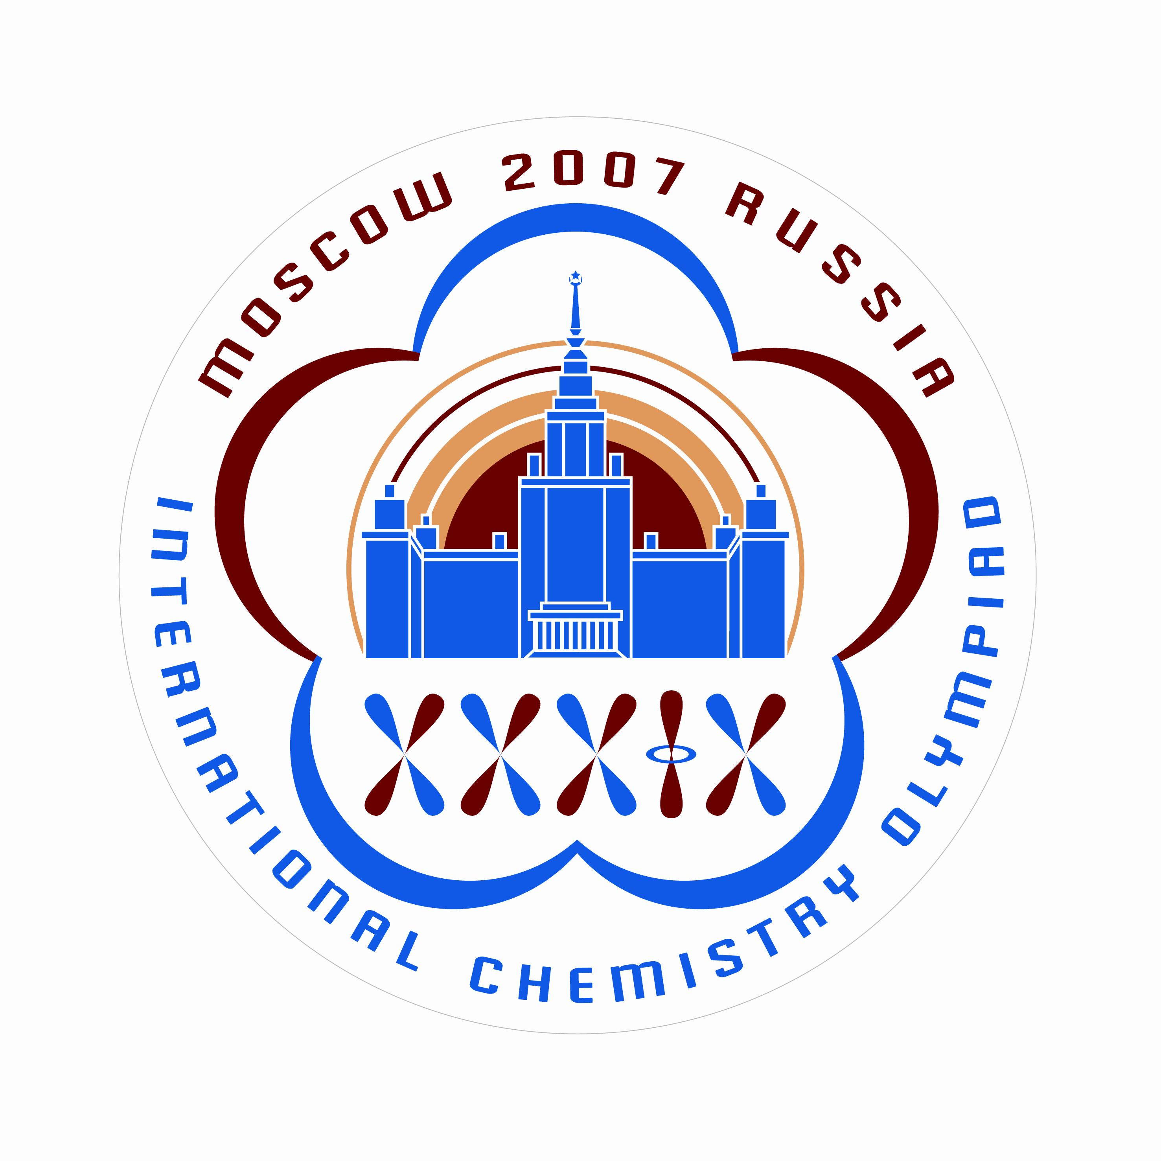
PREPARATORY PROBLEMS
(Theoretical)

July 15-24, 2007
Moscow, Russia

TABLE OF CONTENTS

Problem 1. ON THE BORDERS OF THE PERIODIC SYSTEM 3

Problem 2. SCHRÖDINGER CAT AND CHEMISTRY 4

Problem 3. QUANTUM UNCERTAINTY 6

Problem 4. QUANTUM CHEMISTRY OF VISION 7

Problem 5. NANOPARTICLES AND NANOPHASES 8

Problem 6. IN WHICH DIRECTION DOES A CHEMICAL REACTION PROCEED? 10

Problem 7. LE CHATELIER’S PRINCIPLE 11

Problem 8. DMITRY IVANOVICH MENDELEEV: WHAT BESIDES THE PERIODIC TABLE? 13

Problem 9. KINETICS OF A FREE RADICAL REACTION 14

Problem 10. ASYMMETRIC AUTOCATALYSIS – AMPLIFICATION OF CHIRAL ASYMMETRY 16

Problem 11. RADIOCARBON DATING 17

Problem 12. IRON DETERMINATION 18

Problem 13. SULFUR DETERMINATION 21

Problem 14. MAGNESIUM DETERMINATION 22

Problem 15. INORGANIC PHOSPHATES: FROM SOLUTION TO CRYSTALS 24

Problem 16. FRUITS, VEGETABLES, ATOMS 26

Problem 17. CHAMELEONIC COBALT 29

Problem 18. THE FORMOSE REACTION 32

Problem 19. THE ANALOGY IN ORGANIC CHEMISTRY 35

Problem 20. KETO-ENOL TAUTOMERISM 37

Problem 21. UNUSUAL PATHWAYS OF FATTY ACID OXIDATION: ALPHA-OXIDATION 39

Problem 22. UNUSUAL PATHWAYS OF FATTY ACID OXIDATION: OMEGA- AND (OMEGA-1)-OXIDATION. 41

Problem 23. UNUSUAL PATHWAYS OF FATTY ACID OXIDATION: PEROXIDATION 43

Problem 24. BIOLOGICALLY ACTIVE PEPTIDES AND THEIR METABOLIC PATHWAYS 45

Problem 25. RADICAL POLYMERIZATION 48

Problem 26. IONIC POLYMERIZATION 50

Problem 27. CO-POLYMERIZATION 53

Problem 28. TUNNELING IN CHEMISTRY 55

Problem 1. ON THE BORDERS OF THE PERIODIC SYSTEM

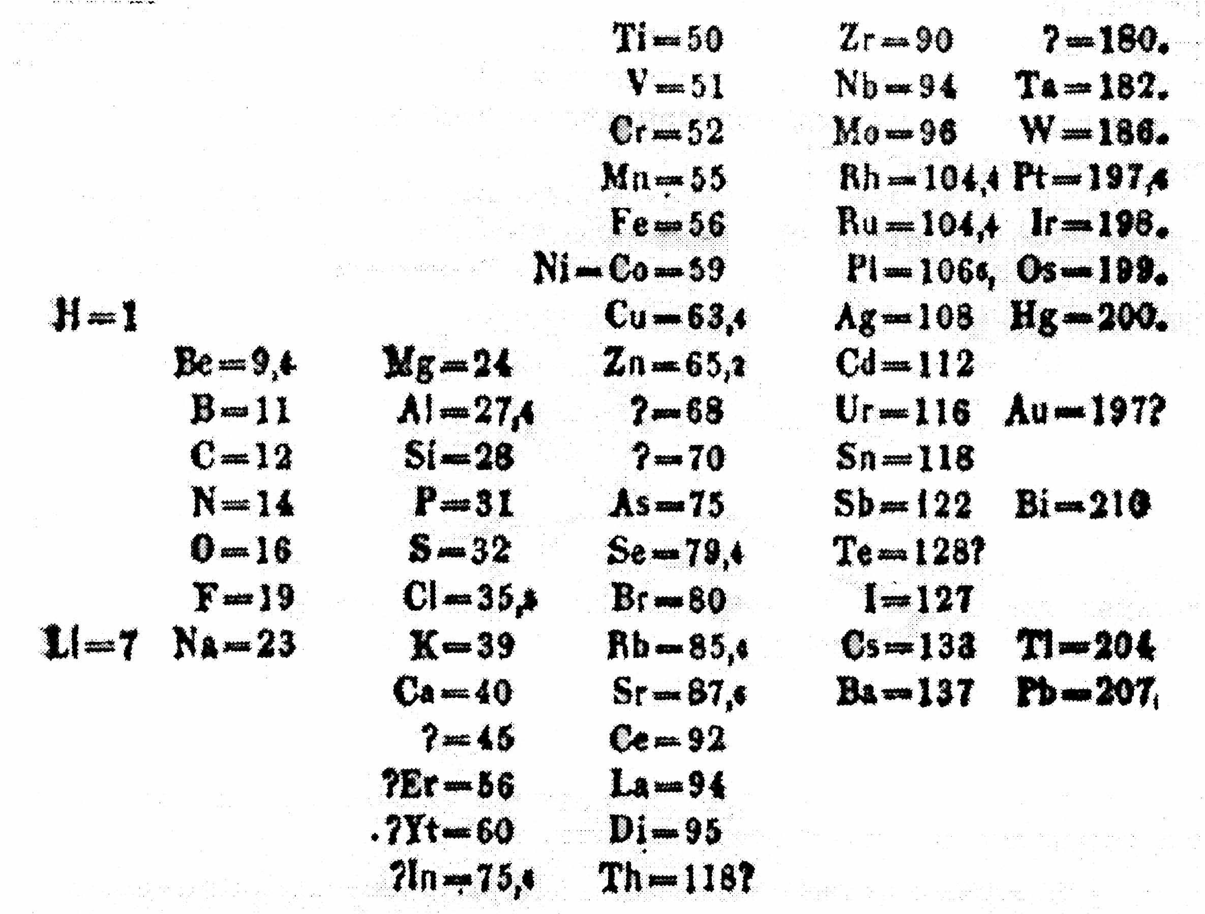

The first Periodic system of the elements was proposed in 1869 by the Russian chemist D.I. Mendeleev, who arranged all the known chemical elements in the order of increasing atomic mass. In 1871 Mendeleev published the article «The natural system of the elements and its application to the prediction of properties of yet undiscovered elements » in the «Journal of the Russian Chemical Society». In that article Mendeleev described in detail the properties of three unknown elements that were ekaboron (Eb), ekaaluminum (Ea), and ekasilicon (Es). All of them were discovered in the next 15 years.

1. What are the present names of the three elements predicted by Mendeleev? Interestingly, all three names have a geographical origin.

The first Periodic system listed 66 elements only, of which three were unknown. In the present-day system there are 118 elements. The last, 118th element was discovered in 2005 during the collaborative studies by the Joint Institute for Nuclear Research (Russia) and the Livermore National Laboratory (USA). After the collisions of calcium-48 nuclei with the target containing californium-249 nuclei three cascades of α-decay were detected, that started from the 118th element with the mass number 294.

2. Write the balanced equations of the nuclear reactions of: i) the synthesis and ii) the α-decay of the 118th element.

3. To which group of the Periodic system does the 118th element belong? Give its electron configuration using a noble gas with the spdf notation.

4. Based on the properties of the same-group analogs of the 118th element and using extrapolation predict the following properties of the 118th element: i) melting point; ii) boiling point, iii) atomic radius, iv) first ionization energy, v) the formula of the oxide of the 118th element in its highest oxidation state.

Problem 2. SCHRÖDINGER CAT AND CHEMISTRY

Many chemical phenomena can be explained by physical theories. The main theory for chemistry is quantum mechanics, which gives the solid foundation for the observed chemical periodicity. One of the cornerstones of quantum mechanics is the superposition principle that says:

“If a quantum system can be found in the states 1 and 2 described by wavefunctions Ψ₁ and Ψ₂, it can also be found in a mixed state with the wavefunction
Ψ = c₁Ψ₁ + c₂Ψ₂,
where factors c₁ and c₂ characterize the contributions of the pure states 1 and 2 to the mixed state”.

The sum or difference of some wave functions taken with certain factors is called a superposition (a linear combination) of these functions.

In a mixed state the quantum system exists in both pure states simultaneously. When you perform some measurement on the system being in the mixed state, this measurement transfers the system to one of the pure states. We can never predict the specific final state; it is determined by the probability laws. The probability of any of the final states after measurement is proportional to the square of the modulus of the corresponding factor:
p₁ ~ |c₁|², p₂ ~ |c₂|².
Of course, the probability to find the system in either of the states is unity:
p₁ + p₂ = 1.

The superposition principle is applicable to quantum systems only and is not valid when applied to macrosystems. To illustrate this idea, E. Schrödinger proposed the following mental experiment. Consider the Geiger counter which detects the entering electrons. The counter is connected to a device which breaks the glass with the poison when the particle enters the counter. Near the glass is a live cat. If the particle enters the counter, the cat is poisoned. But if the counter did not perform the measurement and is in the mixed state between the detected and undetected particle then the state of the cat is a superposition of life and death. Evidently, this is nonsense: the cat can be either alive or dead.

In chemistry, the superposition principle is used in the theories of hybridization, resonance, and molecular orbitals.

The superposition principle in theory of hybridization.
1. An sp³-hybrid atomic orbital is a linear combination of one s and three p-orbitals:
.
i) If we assume that all the orbitals make an equal contribution to a hybrid orbital, what are the absolute values of the coefficients c₁ – c₄?
ii) Similarly, find the absolute values of the coefficients c₁ – c₃ for an sp² hybrid orbital.

The superposition principle in molecular orbital theory.
2. The molecular orbital for the ground state of H₂⁺ molecule ion has the form:
,
where a and b denote hydrogen atoms. What is the probability to find an electron on the 1s-orbital of the atom a?

The superposition principle in theory of resonance.
3. Covalent bonds have a partial ionic character. Thus the wavefunction of a hydrogen halide bond can be presented as a linear combination of two wavefunctions characterizing its ionic (_{H}⁺_{Hal}–) and covalent (_{H:Hal}) states:
L. Pauling in his famous book «The nature of the chemical bond» (1947) claimed that in the HCl molecule the chemical bond is 17% ionic in character. Find the absolute values of c_{cov} and c_{ion} for HCl.

4. One of the benzene wavefunctions can be presented as a linear combination of wavefunctions that correspond to two Kekule and three Dewar structures:

What is the total contribution of the Kekule structures to this electronic state of benzene?

In chemical reactions molecular structure changes over time so that the electronic state of a molecule is a function of time. In some cases structure of a molecule can be presented by a superposition of the initial and final states with time-dependent coefficients.

Let’s assume that a molecule oscillates between two pure states, one with a wave function Ψ₁, and another with a wavefunction Ψ₂, with the frequency ω. Initially (t = 0) the molecule is in the pure first state and after a half-period (t = π/ω) – in the second pure state.

5. Find the time-dependent coefficients of the superposition of these states describing the electronic structure of the molecule. Write the total wave function at a quarter of a period.

Problem 3. QUANTUM UNCERTAINTY

One of the main quantum laws relates the uncertainties of position Δx and momentum Δp of quantum particles. The uncertainty product cannot be less than a fixed value – a half of Planck’s constant:
where momentum is the product of mass and velocity: p = mV, the Planck’s constant is = 1.05⋅10^{–34} J⋅s.

1. Without performing calculations arrange the following particles in the order of increasing minimal uncertainty of velocity, ΔV_{min}:
a) an electron in a H₂ molecule;
b) a H atom in a H₂ molecule;
c) a proton in the carbon nucleus;
d) a H₂ molecule within a nanotube;
e) a O₂ molecule in the room of 5 m width.

2. For the first and the last particles from the list above calculate ΔV_{min}. Take the necessary reference data from handbooks or Internet.

Problem 4. QUANTUM CHEMISTRY OF VISION

The first step in the very complex mechanism of vision is the photoinduced
cis → trans isomerization of the chromophore retinal embedded in rhodopsin molecules. Absorption of visible light by cis-retinal causes a change of the configuration of a double bond:

1. Show the double bond, which participates in the cis-trans-isomerization. Indicate the reaction coordinate.

2. Energies of the reactant and the product were found to be periodic functions of the reaction coordinate x:
,
.
Energies are in eV (1 eV = 1.60⋅10^{–19} J = 96500 J/mol), x = 0 corresponds to the reactant, x = π – to the product. Draw the energy diagram for this reaction. Determine the energy change for the reaction and its activation energy in kJ/mol.

3. What is the largest wavelength of light that can be absorbed by cis-retinal?

Let us apply the “particle-in-a-box” model to the electrons present in the conjugated system of cis-retinal. Energy levels of a particle of the mass m locked in an one-dimensional box of the width l are given by:
, n = 1, 2, …
4. What is the number of electrons in the conjugated system of cis-retinal?

5. Based on your answers on questions (3)-(4) and using the formula above calculate l. How does this value compare with the structure of retinal molecule?

Problem 5. NANOPARTICLES AND NANOPHASES

Nanochemistry has sparked much excitement in the recent years and a large amount of research has been dedicated to understanding of nanomaterials. Single-walled carbon nanotubes (SWNTs) are a universally known example of such materials. SWNT can be thought of as a sheet of graphite rolled into a seamless cylinder (d ≈ 1.5 nm). These cylindrical carbon “molecules” might provide components for molecular electronic devices of the future.

The properties of nanometer-scale materials are size- and shape-dependent.

Saturated vapor pressure of a small spherical particle (crystalline or liquid) is higher than that of the bulk phase of the same material. At equilibrium the molar Gibbs functions (G) of the condensed phase (G_{bulk}) and vapor (G_{vap}) are equal. Equation (1) determines the saturated vapor pressure, p, above a bulk phase
G_{bulk} = G_{vap} = G°_{vap} + RT ln p, (1)
G°_{vap} is the standard molar Gibbs energy of vapor at standard pressure p = 1 bar.

The substance inside a small spherical sample is under excess pressure, caused by surface tension:
ΔP_{in} = 2σ / r
r – the radius of the spherical sample, σ – the surface tension at the “condensed phase-vapor” interface. The increase of the internal pressure results in a change in the molar Gibbs energy of the substance inside the spherical sample. This molar Gibbs energy G*_{sph} is larger than G_{bulk.} The difference in the Gibbs energy of the spherical sample and the bulk phase is equal to :
G*_{sph} = G_{bulk} + ΔP_{in}V = G_{bulk} + 2σV / r, (2)
V is the molar volume of the liquid or solid substance. Therefore from equation (1)
G*_{sph} = G_{bulk} + 2σV / r = G_{vap} = G°_{vap} + RT ln p* (3)
p* is the saturated vapor pressure of the spherical sample with the radius r.

1. The saturated vapor pressure of water at T = 298 K is 3.15⋅10^{–2} bar. Calculate the saturated vapor pressure of the spherical droplets of water with the radius of: i) 1 μm and ii) 1 nm. The surface tension at the liquid-vapor interface of water is 0.072 J/m².

Assuming that the substance retains properties of a bulk while the difference between its saturated vapor pressure and the saturated pressure of the bulk is less than 1%, what is the minimum radius of the spherical sample that can still be considered as a bulk phase? How many molecules of water are there in such a droplet?

2. Few droplets of mercury were put inside a SWNT maintained at 400 K. What is the minimum vapor pressure of mercury inside the tube? The saturated vapor pressure of bulk mercury is 1.38⋅10^{–3} bar, the density of mercury ρ(Hg) = 13.5 g/cm³, the surface tension at the liquid-vapor interface of mercury is 0.484 J/m² at the given temperature.

3. The boiling point of benzene at the standard atmospheric pressure is T_{b} = 353.3 K. The temperature dependence of the saturated vapor pressure of benzene near the boiling point is given by the equation
(4)
where ΔH_{vap} = 30720 J/mol is the enthalpy of vaporization of benzene. Estimate the boiling point (T*) of the finely dispersed liquid benzene at the standard atmospheric pressure if the sample consists of droplets with the radius r = 50 nm. The surface tension of benzene near the boiling point is 0.021 J/m² and its density is 0.814 g/cm³.

4. In general, properties of the bulk and nano-sized material composed by one and the same substance A are different. Which of the following thermodynamic constants will decrease when passing from the bulk to the nano-scaled material?
1) Solubility of A in any solvent;
2) the boiling temperature at atmospheric pressure;
3) the saturated vapor pressure over solid substance A;
4) the equilibrium constant of a chemical reaction, where A is a reagent;
5) the equilibrium constant of a chemical reaction, where A is a product.

Problem 6. IN WHICH DIRECTION DOES A CHEMICAL REACTION PROCEED?

The natural tendency of any chemical reaction to proceed in a certain direction at constant temperature and pressure is determined by the sign of the Gibbs energy of the reaction, ΔG. This is the universal principle. If ΔG < 0, the reaction can proceed predominantly in the forward direction (a product-favored reaction). If ΔG > 0 the reaction can proceed predominantly in the reverse direction (a reactant-favored reaction). When ΔG = 0 the reaction is at equilibrium.

The standard reaction Gibbs energy, ΔG°, can be calculated from the tabulated Gibbs energies of formation of the reactants and products (see the Table).

1. Calculate the equilibrium constant of reaction (1) at 1627 °C. Can the reaction proceed predominantly in the forward direction if the initial partial pressure of O₂ is below 1.00 Torr?
2Ni(l) + O₂(g) = 2NiO(s) (1)

2. The standard Gibbs energy of the reaction
TiO₂(s) + 3C(s) = 2CO(g) + TiC(s) (2)
is positive at 727 °C. Calculate the equilibrium pressure of CO at 727 °C. What should be the reaction conditions to allow for the forward reaction to be the predominant process at this temperature if this is possible at all?

3. Calculate the standard Gibbs energy of the reaction
3H₂ + N₂ = 2NH₃ (3)
at 300 K. Can the forward reaction be the predominant process under the following conditions: p(NH₃) = 1.0 atm, p(H₂) = 0.50 atm, p(N₂) = 3.0 atm?

In fact the reaction does not occur at 300 K at a noticeable rate. Why?

Table 1. Gibbs energies of formation*.
Substance | t, °C | , kJ/mol
NiO | 1627 | –72.1
TiO₂ | 727 | –757.8
TiC | 727 | –162.6
CO | 727 | –200.2
NH₃ | 27 | –16.26

*The standard pressure – 1atm, JANAF Tables.

Problem 7. LE CHATELIER’S PRINCIPLE

Le Chatelier’s principle states that

«Every system in the state of equilibrium when subjected to a perturbation responds in a way that tends to eliminate the effect» (P.W. Atkins “Physical Chemistry”).

Let us see how this principle works. Let a chemical equilibrium be established in the following reaction between the ideal gases:
3H₂ + N₂ = 2NH₃ (1)
At the temperature of T = 400 K partial pressures of reactants and product are respectively: p(H₂) = 0.376 bar, p(N₂) = 0.125 bar, p(NH₃) = 0.499 bar.

The equilibrium was disturbed. Let this disturbance be
a) increase of the total pressure in the system at constant temperature,
b) increase of the amount of NH₃ in the system at constant total pressure and temperature,
c) small increase of the amount of N₂ in the system at constant total pressure and temperature,
d) small increase of the amount of H₂ in the system at constant total pressure and temperature.

1. Calculate the standard Gibbs energy for the reaction (1) at T = 400 K.

2. Write down the expression for the Gibbs energy of reaction (1) for any pressure of reactants and product after perturbation. This expression is called the isotherm of chemical reaction.

3. Using the equation of isotherm from question 2 determine in which direction the reaction (1) will predominantly proceed after the disturbance of equilibrium as indicated in (a)-(d).

4. Will the answers to question 3 change, if the initial equilibrium partial pressures in the system are: p(H₂) = 0.111 bar, p(N₂) = 0.700 bar, p(NH₃) = 0.189 bar? Assume that temperature and total pressure in the system are the same as in questions 1–3.

Problem 8. DMITRY IVANOVICH MENDELEEV: WHAT BESIDES THE PERIODIC TABLE?

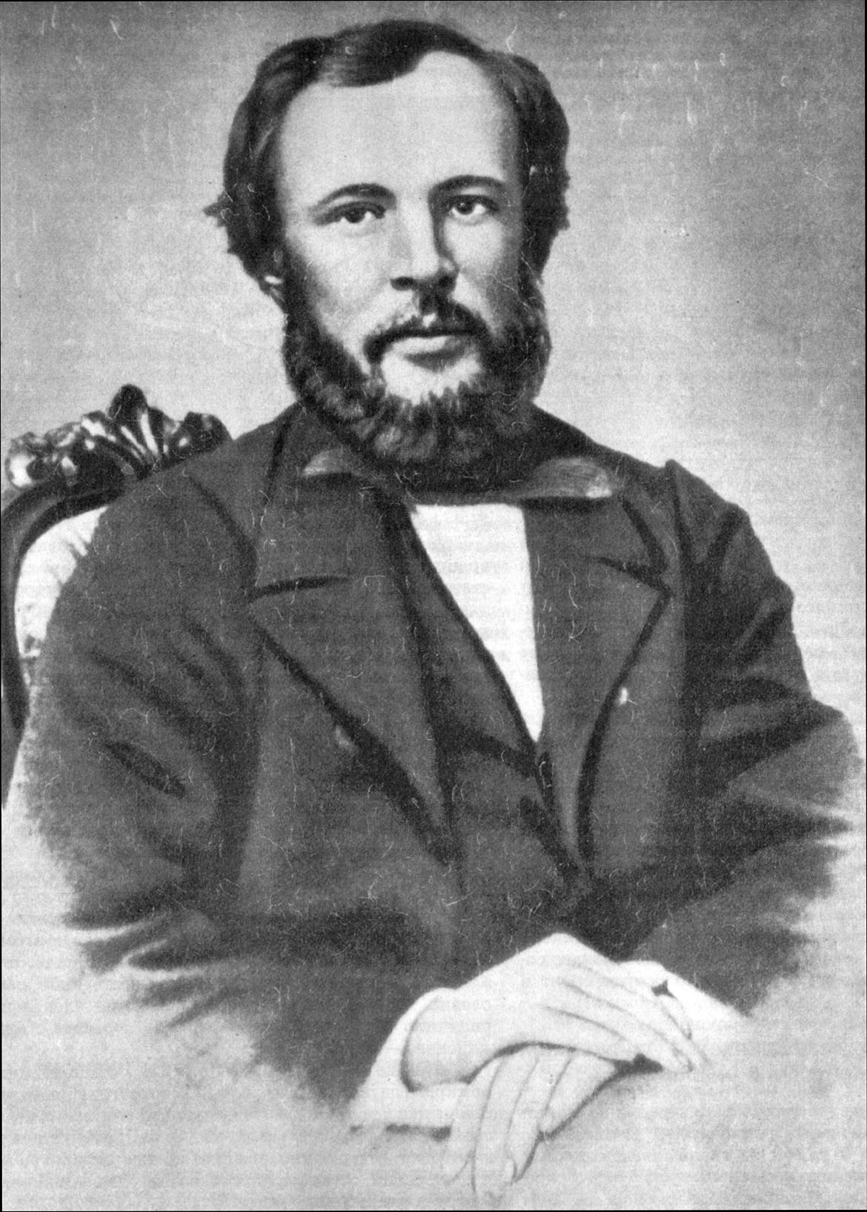
The Russian chemist D. Mendeleev is known for his Periodic Table of elements. This discovery made him famous worldwide. Dmitry Mendeleev has carried out some other interesting studies as well. Consider two of them.

1. Mendeleev was the first to state that every substance has “the temperature of the absolute boiling”. Above this temperature “the substance will stay in the gas phase no matter how high the pressure is”. According to Mendeleev “the temperature of the absolute boiling of water” is 543 °C.

a) What is “the temperature of the absolute boiling”?

b) Indicate the temperature of the absolute boiling in the P-T phase diagram of water.

c) Calculate the temperature of the absolute boiling of water from the Van der Waals equation of state:
,
For H₂O, a = 5.464 l²⋅atm⋅mol^{–2}, b = 0.03049 l⋅mol^{–1}.

2. In Russia many people believe that D. Mendeleev invented the recipe of the famous drink “Russian vodka”. We have a chance to check this legend.

The fact is that in his Ph.D. thesis Mendeleev characterized some properties of the binary system “ethanol-water”. He measured the density ρ of a series of binary solutions of various compositions W, where W(%) is the weight percent of ethanol in the mixture. The derivative dρ / dW is presented in Fig.1 as a function of W.
Fig. 1. Experimental results obtained by Mendeleev

The curve markedly changes the slope three times. According to D. Mendeleev these three special points correspond to the compositions of the weakly bonded chemical compounds, “hydrates of ethanol”.

a) What are the chemical formulas of “the hydrates of the ethanol”?

b) Does the composition of any of the “hydrates” resemble the recipe of vodka (40 volume percent of C₂H₅OH)? The density of ethanol is 0.794 g⋅cm^{–3}. Decide whether or not Dmitry Mendeleev took part in “the discovery of Russian vodka”.

Problem 9. KINETICS OF A FREE RADICAL REACTION

Pyrolysis is an important industrial process for conversion of coal to liquid fuels and chemical feedstocks. The structure of coal can be viewed as a three-dimensional network of polycyclic aromatic building blocks joined together by short aliphatic bridges. In model pyrolysis studies, α,ω-diphenylalkanes are sometimes used as model compounds for coal.

Thermal decomposition of 1,3-diphenylpropane gives toluene and styrene as the major products and ethylbenzene and other hydrocarbons as byproducts. The following mechanism of decomposition has been proposed (the first step is the slowest):

(1)
(2)
(3)
(4)

1. Applying the steady-state approximation for the radical 2, derive the rate equation for the side reaction of ethylbenzene formation.

2. What is the ratio between the steady-state concentrations of the radicals 1 and 3?

Additionally, two free radicals can recombine. The rate constant of recombination k_{R} is supposed to be the same for all radicals.

3. Why could we neglect these reactions in the steady-state equations in questions 1 and 2?

4. One of the radicals is present in the reaction mixture at much higher concentration than others. This radical is:
a) , because it is the most stable one;
b) , because the rate constant of β-scission reaction (4) is higher than the rate constant of chain propagation reaction (3);
c) , because it accumulates in the system.

5. Obtain the rate equation for toluene formation. Determine the reaction order. Express the effective activation energy via the activation energies of elementary steps.

Problem 10. ASYMMETRIC AUTOCATALYSIS – AMPLIFICATION OF CHIRAL ASYMMETRY

Living nature is homochiral: almost all natural amino acids have L-configuration, sugars – D-configuration. One of the possible explanations of this phenomenon is based on the concept of asymmetric autocatalysis. In some reactions chiral products can serve as catalysts of their own formation: the larger is the content of one of the enantiomers the faster is its synthesis.

1. The simplest equation for autocatalysis is: A + P → 2P, where P is product. Reaction can be performed under various conditions: either in a closed system when reagents are mixed only once, or in an open system where reagent A is being continuously added to the mixture so that its concentration is maintained constant.

Write the kinetic equations and draw the kinetic curves for product P in the closed and open systems. Assume that the initial concentration of P is non-zero but small.

The first reaction of asymmetric autocatalysis was discovered in the early 1990-s. Addition of diisopropylzinc to pyrimidine-5-carbaldehyde in toluene leads to the mixture of enantiomers X₁ and X₂, which after hydrolysis is transformed to enantiomeric alcohols Y₁ and Y₂:

2. Draw the structure of enantiomeric pairs X and Y, and show the configuration of the stereocenter.

It turned out that the presence of small amounts of any product (Y₁ or Y₂) selectively accelerates the formation of that specific product which leads to enantiomeric enrichment of the reaction mixture. Suppose that the yield of each product is proportional to the square of its molar fraction in the mixture of alcohols prior to synthesis.

3. To 1 mmol of mixture Y₁ and Y₂, containing 55% of Y₁, 1 mmol of aldehyde and 1 mmol of diisopropylzinc are added several times. Assuming that total reaction yield is 100%, calculate how many times we should add the reagents to enrich the mixture of alcohols up to: a) 70%, b) 90%, c) 99% of Y₁.

Note. You need to write a small iteration program.

Problem 11. RADIOCARBON DATING

The carbon-14, a radioactive isotope of carbon, is often used to date archaeological, geological, and hydrogeological samples. The half-life of ¹⁴C is t_{1/2} = 5730 years, but in calculations of the age of samples, a different value of half-life, t’_{1/2} = 5568 years, is used. The ¹⁴C is produced from nitrogen in the atmosphere under the action of cosmic rays. It can be included in the organisms of plants and animals through the photosynthesis and the food chains. The radiocarbon content in living organisms is nearly constant with the activity of ¹⁴C being 230 Bq per kg of carbon. After death of an organism, the carbon exchange stops and the ¹⁴C content starts decreasing continually.

1. Give the balanced reaction equations of formation and decay of ¹⁴C.

2. Activity of radiocarbon in a sample of cloth from an Egyptian pyramid corresponds to 480 disintegrations per hour per gram of carbon. What is the age of the cloth?

In another pyramid, a white powder was found. Analysis showed it was a pure phenoxymethylpenicillin (Penicillin V):

Commercial phenoxymethylpenicillin is produced by microorganisms cultured in a medium containing carbohydrates (lactose, glucose, sucrose), cornsteep liquor, mineral salts and phenoxyacetic acid.

It was decided to determine the radiocarbon content to estimate the age of the powder. The ¹⁴C/¹²C ratio determined from mass-spectrometry measurements amounts to 6.0·10^{–13}.

3. The archaeologists estimated the age of the powder from the radioactive decay law. What was the production date they obtained?

4. Explain this result. When was the powder produced in reality?

Constants were taken from:
Lloyd A. Currie. The Remarkable Metrological History of Radiocarbon Dating. // J. Res. Natl. Inst. Stand. Technol. 109, 185-217 (2004)

Problem 12. IRON DETERMINATION

Iron is one of the most important elements necessary for the support of the vital functions of human organism. Its deficiency may cause anemia for treatment of which Fe(II) supplementation is usually employed. The therapeutic effect of Fe(III) compounds is much less pronounced.

Fe(II) is a fairly strong reducing agent which can be readily oxidized to Fe(III). Therefore methods for separate determination of Fe(II) and Fe(III) as well as for the determination of the total iron content are needed for quality control of pharmaceuticals. Here we will see how this problem can be solved.

1. Prior to determination of the total iron content it is usually transformed quantitatively either to Fe(II) or to Fe(III). Using standard redox potentials given below establish which of the oxidizing agents listed can oxidize Fe(II) to Fe(III) under standard conditions. Write down the balanced net ionic equations of corresponding reactions.

oxidized form | reduced form | E°, V
Fe³⁺ | Fe²⁺ | +0.77
HNO₃ | NO (+H₂O) | +0.96
H₂O₂ (+H⁺) | H₂O | +1.77
I₂ | I– | +0.54
Br₂ | Br– | +1.09

2. After oxidation of all the iron to Fe(III) its total amount can be determined by precipitation of iron in the form of Fe(OH)₃ followed by annealing of the precipitate to Fe₂O₃ and weighing.

a) Estimate the pH of 0.010 M FeCl₃ in water. Assume that Fe(OH₂)₆³⁺ cation is a monoprotic acid with the dissociation constant K_{a} = 6.3.10^{–3}.

b) Calculate the pH necessary to begin precipitation of Fe(OH)₃ from the solution above. Solubility product of Fe(OH)₃ is K_{sp} = 6.3.10^{–38}.

c) At what pH value precipitation of Fe(OH)₃ from 100.0 mL of 0.010 M FeCl₃ will be complete? Consider the precipitation as complete if no more than 0.2 mg Fe remains in solution.

Note. All the pH values should be estimated with accuracy of 0.1 units pH. Neglect the effect of ionic strength.

3. Fe(II) can be determined in the presence of Fe(III) by titration with KMnO₄ solution in acidic media. Since aqueous solutions of KMnO₄ tends to decompose slowly over time, the exact concentration of KMnO₄ has to be found immediately before determination of Fe(II). This is usually done by titration with KMnO₄ of a solution of a primary standard, a pure substance of known composition. Such standard solution can be prepared by dissolving an exact amount of the primary standard in water in a volumetric flask of an exactly known volume.

For the titration of 10.00 mL of a primary standard solution containing 0.2483 g of As₂O₃ in 100.0 mL of water 12.79 mL of KMnO₄ solution were used, whereas for titration of 15.00 mL of the solution containing 2.505 g Fe per liter were used 11.80 mL of that same solution of KMnO₄. What fraction of iron in the sample was present in the form of Fe(II)?

4. To a solution containing Fe(II) and Fe(III) tartaric acid was added. The solution was neutralized with aqueous ammonia and then excess KCN was added. The potential of the platinum electrode immersed in that solution was found to be +0.132 V against saturated calomel electrode.

a) Assuming that all iron in the last solution was present in the form of Fe(CN)₆^{n–}, calculate the fraction of iron present in the form of Fe(II) in the original sample. Standard redox potential of Fe(CN)₆^{3–}/Fe(CN)₆^{4–} is +0.364 V. Potential of saturated calomel electrode is +0.241 V. The temperature of the sample solution is 25 °C.

b) What concurrent reactions were prevented by the addition of tartaric acid and ammonia to the sample solution? Write down the net ionic equations of those reactions.

Problem 13. SULFUR DETERMINATION

Compounds of sulfur in its lower oxidation states are present in many industrial wastes (metallurgy, production of paper, chemical) and are dangerous ecotoxicants. The prevalent forms of sulfur in lower oxidation states in solutions are S^{2–}, SO₃^{2–} and S₂O₃^{2–} ions. Their content can be determined by redox titration under different conditions.

1. To a 20.00 mL sample containing S^{2–}, SO₃^{2–} and S₂O₃^{2–} an excess of ZnCO₃ suspended in water was added. Upon completion of the reaction the solution was filtered into a 50.00 mL volumetric flask and diluted to the mark. To 20.00 mL of the filtrate an excess of aqueous formaldehyde was added. The mixture was acidified with acetic acid and titrated with 5.20 mL of 0.01000 M standard solution of iodine.

a) Write down the net ionic equations of the reactions taking place during the analysis.

b) Which ion, S^{2–}, SO₃^{2–} or S₂O₃^{2–}, can be determined by this method?

c) Calculate the concentration of this ion in ppm in the initial solution.

2. A 20.00 mL sample of the 0.01000 M iodine solution was acidified with acetic acid and then combined with 15.00 mL of the filtrate above. The mixture was titrated with 6.43 mL of the 0.01000 M sodium thiosulfate standard solution.

a) Write down the net ionic equations of the reactions taking place during the analysis.

b) Which ion, S^{2–}, SO₃^{2–} or S₂O₃^{2–}, can be determined by this method taking into account the result of the previous experiment?

c) Calculate the concentration of this ion in ppm in the initial solution.

3. A 10.00 mL sample of 0.05000 M iodine solution was acidified with acetic acid and then 10.00 mL of the original sample containing S^{2–}, SO₃^{2–} and S₂O₃^{2–} were added. The mixture was titrated with 4.12 mL of 0.05000 M sodium thiosulfate standard solution.

a) Write down the net ionic equations of the reactions taking place during the analysis.

b) Which ion, S^{2–}, SO₃^{2–} or S₂O₃^{2–}, can be determined by this method taking into account the results of two previous determinations?

c) Calculate the concentration of this ion in ppm in the initial solution.

Problem 14. MAGNESIUM DETERMINATION

To determine the amount of magnesium in a solution, a sample of the liquid was first acidified with HCl, then made slightly alkaline by addition of NH₃ and then combined with an excess (NH₄)₂HPO₄ in water. The precipitate of MgNH₄PO₄ formed was filtered off, washed with diluted aqueous NH₃, annealed at 1000 °C to constant mass and weighed.

Answer the following questions using numerical data given in the end of the text whenever necessary.

1. Write down the net ionic equation for the precipitation reaction taking place in course of the analysis.

2. Write down the equation for the reaction taking place in the course of annealing.

3. When determining the content of magnesium in a granulated medicine preparation calmagin 0.1532 g of the annealed precipitate were obtained from a 1.8005 g sample of calmagin. Calculate the mass percent of MgO in the preparation.

4. During the precipitation of MgNH₄PO₄ some impurities may coprecipitate such as MgHPO₄, Mg(NH₄)₄(PO₄)₂, Mg₃(PO₄)₂, Mg(OH)₂, (NH₄)₂HPO₄ and NH₄Cl. Some of these substances can undergo thermal decomposition at annealing. Write down the equations of the corresponding reactions.

5. Indicate if the presence of the impurities listed in Table below can lead to an error in the magnesium content as determined by the method described above. Put 0 in the Table if no error is expected, plus or minus sign if the error will be positive or negative respectively.
Impurity | Error
MgHPO₄
Mg(NH₄)₄(PO₄)₂
Mg₃(PO₄)₂
Mg(OH)₂
(NH₄)₂HPO₄
NH₄Cl

6. At what maximum pH value the precipitation of MgNH₄PO₄ may be carried out to avoid simultaneous precipitation of Mg(OH)₂? Assume that the volume of the original sample was 200 mL and the content of magnesium in it was 0.10 g.

7. To determine the solubility product (K_{sp}) of MgNH₄PO₄ a NaOH solution was added dropwise until the beginning of precipitation to a 100 mL of solution containing 0.010 M MgCl₂, NH₄Cl and NaH₂PO₄ each. The precipitation started at pH 6.48. Calculate K_{sp}. Neglect the volume change during the experiment.

Reference data
H₃PO₄ | acidity constant | K_{a1} | 7.1.10^{–3}
 |  | K_{a2} | 6.2.10^{–8}
 |  | K_{a3} | 5.0.10^{–13}
NH₃ | basicity constant | K_{b} | 1.8.10^{–5}
Mg(OH)₂ | solubility product | K_{sp} | 6.0.10^{–10}
H₂O | ionic product | K_{w} | 1.0.10^{–14}

Problem 15. INORGANIC PHOSPHATES: FROM SOLUTION TO CRYSTALS

Inorganic acids containing phosphorus and oxygen and most of the salts of these acids are composed of oxygen tetrahedra, each with the phosphorus atom in the center. The tetrahedra can either be isolated or share an oxygen atom so being linked by means of P−O−P bridges.

1. a) Draw the structure of the anions present in the neutral salts of the following acids: H₃PO₄, H₃PO₃, H₃PO₂.

b) For the series of acids above, reveal the trends in:

1) acidity of the substances (compare the values of pK_{a1}),
2) O−P−O valence angle.

2. The formula of metaphosphoric acid can be written as (HPO₃)_{n}. This acid is composed of the phosphorus-oxygen tetrahedra either. Suggest the structure of this compound assuming the minimal number of phosphorus atoms in its molecule.

3. a) To estimate the relative charge of atoms in P_{n}O_{k}^{(2k–5n)–} anion, let us define a special secondary parameter A_{i} of an atom i as the oxidation number of this atom, Z_{i}, divided by its coordination number, CN_{i},:
.

The sum of the oxidation number (Z_{N}) of an atom N (for instance, phosphorus atom) and A_{i} values for the atoms forming the coordination environment (for instance, oxygen atoms) of the atom N gives the relative charge Q(N) of the atom N:
.

Calculate Q_{m}(P) for the PO₄ tetrahedron considering m = 1, 2, 3 and 4 of its oxygen atoms being shared with neighboring PO₄-tetrahedra.

b) Perform similar calculations for TO₄-tetrahedra linked through the common vertices, where
1) T = Si,
2) T = S.

4. Let us suppose that a tetrahedron with the minimal absolute value of Q_{m}(P) is the most stable towards hydrolysis.

a) Which value of m corresponds to the phosphorus-oxygen tetrahedron the most stable towards hydrolysis?

b) Which value of m corresponds to the TO₄ tetrahedron (T = Si, S) the most stable towards hydrolysis?

5. Isolated phosphorus-oxygen tetrahedra (without P−O−P bonding) can be found in crystalline substances. Mixed phosphates (V) M_{a}PO_{b} are known to be composed of PO₄- and MO₄-tetrahedra with each oxygen atom having the same number of M and P atoms coordinated to it.

a) Determine the Q(O) value for such compounds.

b) Suggest possible empirical formulas for such compounds.

6. Fluorapatite Ca₅(PO₄)₃F is a constituent of human teeth. It can be synthesized using a double-diffusion method with a gelatin membrane separating solutions containing F–, HPO₄^{2–}, and Ca²⁺ ions. The synthesis leads to a hybrid material – bioorganic polymer/inorganic phosphate, resembling tooth (or bone) tissue.

a) Give a reasonable composition of two solutions placed on different sides of the gelatin membrane, that allow preparation of fluorapatite as the target substance in this double-diffusion experiment.

 | 5 mM Ca(NO₃)₂ | 1 mM NaF | 3 mM Na₂HPO₄
Solution 1
Solution 2

b) Write down the balanced equation of the reaction described above leading to fluorapatite.

c) Calculate the osmotic pressure acting on the membrane at the beginning of this experiment (25 °C, activity of all ions is equal to 1).

Problem 16. FRUITS, VEGETABLES, ATOMS

When solving this problem none of the fruits or vegetables was destroyed!

In 1611 German mathematician and astronomer Johannes Kepler observed the stacking of cannonballs in a pyramid. He asserted there is the only way to fill the space the tightest possible with equal hard spheres, “…so that in no other arrangement could more pellets be stuffed into the same container”. He was the first to formulate such a problem termed later as Kepler Conjecture. In 1998 Professor Thomas Hales announced a solution to the Kepler Conjecture, which was published in a series of papers in “Discrete and Computational Geometry” starting from 1997. He considered 150 more variants of space filling besides that asserted by Kepler. Hales’ solution required about 250 pages in a printed version and a size of 3 Gb in computer files. Thus, the term of close-packing of spheres (c.p.s.) widely accepted in the field of solid state chemistry passed through the rigorous mathematical proof and remained valid.

We do not request that you provide an alternative solution to this problem. However, you can check with our help how the basic law of space filling is applicable to our everyday life.

1. In order to avoid smashing tomatoes during their transportation, it is useful to arrange them on a shelf in a uniform single layer. Let us consider two types of packing (Fig. 2).

a) Calculate the density of tomatoes packing (φ) for the case A and B as
φ = S_{tomato} / (S_{void} + S_{tomato}).

b) Which type of the packing requires less shelf area?

Fig. 2. Two possible types of packing tomatoes.

2. Hard vegetables such as potatoes or cabbage heads can be packed in containers. Consider several types of packing:
(1) The first layer is of the type A (see Fig. 2). The second layer is an exact copy of the first, a vegetable in the second layer is above another one in the first layer (such a packing is termed usually as simple cubic packing , or s.c.).
(2) The first layer is of the type A. In the second layer each vegetable is above a void space in the first layer (body centered cubic packing, or b.c.c.).
(3) The first layer is of the type B. The second layer is an exact copy of the first, a vegetable in the second layer is above another one in the first layer (hexagonal packing, or h.p.).
(4) The first layer is of the type B. In the second layer each vegetable is above a void space in the first layer (hexagonal close packing, or h.c.p.).

a) Calculate the densities of packing for the cases (1) – (4).

b) Which type of packing is more efficient in the sense of van filling?

c) There are two alternatives to arrange the third layer in the case B: i) by placing vegetables right above the vegetables of the first layer (that is to place them into the voids of the second layer) or ii) by arranging vegetables right above the voids of the first layer (see the case B in Fig. 2). Calculate the density of packing φ for the second alternative which is called the face centered cubic packing – f.c.c.

d) A farmer filled the third layer in the way of f.c.c. and now can not figure out where the voids and vegetables of the first layer are. How does the value of φ vary due to the faults in regular sequence of closed packed layers?

3. Assume now that the enterprising farmer decided to place peaches into the van with watermelons. His bright idea was to place peaches into the voids of watermelon packing.

a) Estimate the maximal value of the R_{peach} / R_{watermelon} peach/watermelon radii ratio that allows to avoid peach smashing in cases of:
(1) cubic void within s.c.
(2) octahedral void within b.c.c.
(3) octahedral void within f.c.c.

b) How many peaches (maximum) per one watermelon can the farmer place using c.s., h.c.p., b.c.c. and f.c.c. types of packing?

c) What is the maximal φ value for c.s., b.c.c. and f.c.c. packings containing peaches in voids?

4. The fruits can go bad due to insufficient ventilation in the van.

a) In order to keep the voids in b.c.c. and f.c.c. packings the go-ahead farmer decided to put peaches only in the octahedral voids which are not linked by edges and faces. How many peaches per one watermelon can be packed in this case?

b) The enterprising farmer has got another idea: to feel all the octahedral voids in f.c.c. with peaches (you know about it), whereas (it’s brilliant!) the tetrahedral voids with apples. How many apples per one watermelon can he arranged in this way?

Nature invents puzzles like the Kepler Conjecture. Opal is a natural stone composed of c.p.s.-packed SiO₂ microspheres. The main feature of opal is the distinguished shining (the so-called iridescence) when it is illuminated. This phenomenon is explained by the diffraction of visible light in accordance with Bragg’s law:
λ = 2d sin θ
where λ is the wavelength of light, d is the distance between layers in c.p.s. of opal, 2θ is the angle between incident and diffracted beams (or, in other words, θ the inclination angle of the beam with respect to the surface of opal stone).

Opal is a prototype of photonic crystals, materials composed by closely packed microspheres with high refraction index. Optical spectra of photonic crystals demonstrate unusual features, for instance, photonic band gap (like electron band gap in semiconductors). Photonic crystals are considered to be the main active elements in photonics, the information technology of the future.

5. a) Find the minimal values of Miller indices – (h k l) related to the first “permitted” reflection in f.c.c.

b) Calculate the wavelength of light if the first reflection is observed for 2θ = 60°. The radius of SiO₂ microspheres is equal to 450 nm. The dispersion of SiO₂ refraction index (that is, its dependence on wavelength) can be neglected.

Problem 17. CHAMELEONIC COBALT

Information was always regarded as the most valuable product resulting from mankind activity. It is not striking that recognition of this fact was followed by numerous efforts aimed at information safety. Cryptography seemed to be a convenient way to reach such safety from unrecorded time. Cryptography cannot be detached from sympathetic ink that becomes visible only after special treatment, for instance, heating. History knows a number of recipes of such ink, among them that based on salts of cobalt(II). Being pale-pink in color, cobalt ink is virtually invisible when dried on paper. However, once heated with a candle flame, a letter written with such ink reveals hidden text colored in bright-blue.

We know other applications of cobalt(II) salts, less secret, but dependent on the color transition described above. Blue granules of silica-gel doped with Co(II) salt and placed into a desiccators to dry some product, become pink at last. This is the signal to regenerate silica-gel (just to dry, since it accumulates too much water). Similarly, a paper soaked with saturated solution of CoCl₂ turns blue in dry air due to formation of CoCl₂·4H₂O, and changes its color back to pink CoCl₂·6H₂O in a humid environment. Apparently, the paper works as a humidity meter, hygrometer.

1. Using the thermodynamic data below, determine the threshold of air humidity (in %) specific to the response of such a hygrometer.

Compound | , kJ mol^{–1} | , J mol^{–1} K^{–1}
CoCl₂·6H₂O_{(cr)} | 2113.0 | 346.0
CoCl₂·4H₂O_{(cr)} | 1538.6 | 211.4
H₂O_{(lq)} | 285.8 | 70.1
H₂O_{(g)} | 241.8 | 188.7

The “pink (sometimes, violet) ↔ blue” color transition described above is related to the reconstruction of the coordination sphere of Co²⁺ ion: octahedron ↔ tetrahedron. The examples discussed in a previous section deal with the transition [Co(H₂O)₆]_{oct}²⁺ ↔ [Co(H₂O)₄]_{tetr}²⁺. As a rule, coordination compounds with tetrahedral geometry are less abundant compared to octahedral ones. However, in particular case of Co²⁺ tetrahedral complexes competes with octahedral compounds.

2. To understand the reason behind such behavior, consider the following octahedral and tetrahedral complexes:
a) [Cr(H₂O)₆]³⁺ and [Cr(H₂O)₄]³⁺,
b) [Co(H₂O)₆]²⁺ and [Co(H₂O)₄]²⁺.
Draw diagrams for the case of an octahedral and a tetrahedral ligand field showing clearly the energy levels of all metal 3d-orbitals; indicate the d-orbital splitting parameter Δ. For each of the ions above use the appropriate diagram and fill it in with the electrons available in the metal d-subshell. Calculate the Crystal Field Stabilization Energy (CFSE) for each of the ions.

Compare the results and draw a conclusion.

3. The following reaction
[Co(H₂O)₆]²⁺ + 4X– = [CoX₄]^{2–} + 6H₂O, (1)
where X– = Cl–, Br–, I–, SCN–, is used in some textbooks to illustrate Le Chatelier’s principle related to equilibrium shifting. If one adds an excess of salt containing X–, the solution becomes blue, and under dilution with water it turns back pale-pink.

a) Predict the signs of the enthalpy () and entropy () changes for the reaction (1).

b) What effect does temperature produce on the equilibrium (1)?

c) Consider reaction (1) and KCl and KSCN as a source of ions X– for it. Which salt present in the same molar concentration shifts the equilibrium (1) to the right in a greater extent? Explain using the principle of Hard and Soft Acids and Bases (HSAB).

4. Consider a similar equilibrium (2):
[CoX₂L₄] = [CoX₂L₂] + 2L. (2)

a) If L = pyridine (py), which ligand X (Cl– or I–) helps better shift the equilibrium (2) to the right? Explain using the principle of Hard and Soft Acids and Bases (HSAB).

b) If L = PH₃, which ligand X (Cl– or I–) helps better shift the equilibrium (2) to the right? Explain using the HSAB principle.

c) The coordination compound with the formula [CoX₂L₂], where L = py, X = Cl– exists in two forms colored blue and violet. The structure of the former is quite apparent, whereas that of the latter is less obvious. For the violet form, draw a fragment of its structure large enough to show clearly the coordination mode of the cobalt ion.

With some knowledge of coordination chemistry of Co(II) described above, you may be able to account for the transformations described below.

NaOH solution is added dropwise to a solution of Co(II) under cooling (0 °C), which results in a precipitate of blue color. If the precipitate is left at room temperature (25 °C) for a while, it becomes pink. If an excess of alkali is further added to the precipitate, it dissolves giving blue solution.

5. Write down equations corresponding to the transformations described above.

Problem 18. THE FORMOSE REACTION

Aldehydes have a high and versatile reactivity serving as indispensable reagents in the organic synthesis. Carbon atom of the carbonyl group is an electrophilic center. In the aldol condensation reactions a nucleophilic enol (or enolate) attacks the electrophilic carbonyl group of the other aldehyde (or ketone) molecule.

1. Fill in blank boxes in the representative aldol condensation reaction, and mark by letters E or N the respective nucleophilic and electrophilic reaction centers which take part in the process

The aldehydes lacking α-hydrogen atoms are commonly believed to be unable to take part in the aldol reactions as a nucleophilic component, thus such aldehydes are apparently unable to undergo self-condensation.

2. Such aldehydes are commonly referred to as non-enolizable. Why? Give any three examples of such aldehydes.

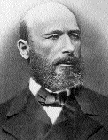
Formaldehyde is the most famous among such aldehydes. It was discovered by one of the founding fathers of organic chemistry, Alexander M. Butlerov as early as in 1859. Studying the compound Butlerov discovered a very interesting transformation of aqueous formaldehyde in the presence of lime into sugary syrup. The other great chemist Emil Fischer studied this transformation in more detail about half a century later, and discovered that a complex mixture of racemic carbohydrates is actually formed. The mixture was given a name “formose”; the transformation since then is called the formose reaction. This reaction is very interesting due to its possible role in the generation of sugar molecules in a prebiotic Earth. Also it is quite promising from a practical viewpoint as a very inexpensive source of sugars for biotechnology given that formaldehyde is a readily accessible raw material which is produced in huge amounts from carbon and water.

3. Suggest a method for industrial preparation of formaldehyde from coal and water in no more than 3 stages.

The way formaldehyde enters the condensation remained an enigma for a long time since Fischer’s works. One of the possible keys to this problem is the so-called Umpolung. The essence of this important synthetic notion can be illustrated using the benzoin condensation as an example:
4. Mark in structure of the product (benzoin) the fragments coming from benzaldehyde and put the letters E and N over electrophilic and nucleophilic centers.

The intermediate generation of a nucleophilic reagent from a compound ordinarily behaving as an electrophile (or vice versa) is referred to as the Umpolung principle in modern organic chemistry.

In order to avoid handling deadly cyanides, other compounds having similar CH-acidity, thiazolium salts, can be used. Such a non-trivial choice comes from a far-reaching analogy. One of such thiazolium salts, vitamin B₁ derivative, or thiamine pyrophosphate, is employed by Nature as a co-factor for trans-ketolases, that perform in vivo reactions closely resembling the benzoin condensation by transferring a carboxylic acid residue (acyl) as a nucleophilic rather than electrophilic reagent.

5. Mark in thiazolium the CH-acidic center equivalent to that in HCN. Draw the structure of the respective carbanion and show its resonance structures that account for the enhanced CH-acidity.

6. Alcohol addicts often suffer from an acute B₁ deficiency. Why?

A model of formose reaction has been studied. Formaldehyde in the presence of calcium hydroxide and vitamin B₁ (denoted as HZ in the Scheme below) gives the simplest ketotriose (dihydroxyacetone, DHA) in good yield.

7. Complete this scheme to the final product.

With all these data at hand, we can try to crack the enigma of the real formose reaction. An essential clue is that the reaction of pure aqueous formaldehyde in the presence of lime is autocatalytic, which means that it is extremely slow at the beginning (there is an induction period), but once it starts it runs at an increasing rate until exhaustion of formaldehyde. Traces of any carbohydrate dramatically accelerate the reaction and immediately launch it if introduced within the induction period. The process involves a catalytic cycle consisting of aldol condensations (AC), keto-enol tautomerizations (KET), proton transfers leading to enolates (E), enolate or enol isomerizations (EI).

8. Fill in empty boxes on the simplified scheme of formose reaction below.

9. Show the step(s) involved in the induction period.

10. Show the catalytic cycle. What compound(s) serve(s) as catalyst(s)?

Problem 19. THE ANALOGY IN ORGANIC CHEMISTRY

Though not strict but rather an intuitive concept, the analogy (structural, electronic, stereochemical) is widely used by chemists for reasoning. For example, organic chemists often predict new reagents or even reactions by analogy with known ones.

An important sort of analogy is heteroanalogy – the similarity of compounds or reactions differing by substitution of an atom or group by another atom or group having the same type of bonding.

Thus, heteroanalogues of aldehydes are iminium salts, e.g. a well-known Eschenmoser’s salt CH₂=NMe₂⁺I–.

1. Which type of reagent is the cation of Eschenmoser’s salt? Electrophile □,
nucleophile □, free radical □, Lewis acid □, oxidant □, protecting group □

2. Write by analogy the reaction of Eschenmoser’s salt with acetone. Why does this reaction not require a catalyst?

Further we may consider a heteroanalogy concept with respect to reactions. E.g. there is the Cope rearrangement, which takes place if 1,5-dienes are being heated. The reaction is a concerted movement of 6 electrons to involve two π-bonds and a σ-bond, a sigmatropic shift.

3. What products are formed on prolonged heating of 1,5-hexadiene substituted at C1 with one deuterium atom in inert atmosphere (possible isotope effects are to be neglected)?

If we take vinyl allyl ether CH₂=CH−O−CH₂CH=CH₂ in place of diene, the same sort of rearrangement takes place, but with a more interesting result leading to a compound of the other class, unsaturated ketone. Such hetero- (oxa-)analogue is usually called the oxo-Cope rearrangement, or Claisen rearrangement. This reaction was discovered by a happy chance by great German chemist Ludwig Claisen.

4. Complete the reaction

The rearrangements of this sort are interesting because new reactive groups can form in a very simple process, and these newly-born groups can enter further reactions in the same reaction mixture without the isolation of intermediate compounds. Such chains of transformations are often called the domino-reactions, by analogy with a well-known trick when a long chain of standing dominoes is made to fall by a single click.

5. Your task would be to imagine how the following domino-process, which is initiated by a drop of strong acid and a dehydrating agent, such as HC(OEt)₃, takes place
Write the steps involved in this process.

Problem 20. KETO-ENOL TAUTOMERISM

Aqueous or alcoholic solutions of ketones or aldehydes can be titrated by solutions of halogens or interhalides. In order to obtain reproducible results, the titration should be performed fast in the presence of buffer salts, such as NaHCO₃.

Thus, to 10 g of cyclohexanone in aqueous methanol were added 2.00 mmol NaHCO₃, and 1.00 ml 2.00 N methanolic solution of ICl. After thorough mixing an excess of aqueous NaI solution was added, followed by titration by 1.594 ml of 1.00 N Na₂S₂O₃ using starch as indicator.

1. Write the reactions involved in the analysis.

2. What compound reacts with ICl? Estimate the content of this compound in cyclohexanone.

3. What is the role of buffer salt? What can happen if Na₂CO₃ is taken in place of
NaHCO₃?

A colorless substance A with the empirical formula C₂H₂O shows in ¹³C NMR only two signals at 94 and 159 ppm. The reactions of A with halogens or interhalides are instantaneous, but titration, as described above, is not useful as more than one mole halogen per mole A is consumed to give off heavy precipitates.

A readily reacts with aldehydes in the presence of either acidic or basic catalysts, to form products of 1:1, 1:2 or 1:3 stoichiometry (depending on reagent ratio). Such products are often colored, which is used in many well-known qualitative reactions for aldehyde-containing materials. For example, carbohydrates give red coloration when treated by A and a drop of HCl.

Under alkaline conditions A reacts with methyl iodide to give a mixture of products. With a large excess of MeI a single compound B is produced. B turned out to be identical to a known trimer of dimethylketene formed under the conditions of basic catalysis. On the other hand, if the reaction of A with excess MeI is performed in the presence of NaHCO₃ a different compound C is formed. This compound possesses a fine odor and has been identified as one of important constituents of rose flavor. In ¹H NMR compound B shows a single resonance, while C shows two sharp singlets with integral intensities ratio of 1:3.

The reaction of A with NaHSO₃ on heating gives colorless water-soluble material (brutto-formula C₆H₅NaO₅S) showing a purple coloration with FeCl₃ solution. The ¹³C NMR spectrum in D₂O shows 4 signals at 157, 144,106,105 ppm.

The reaction of A with hydroxylamine gives a compound D (brutto-formula C₂H₃NO), which is cleanly reduced by H₂ over Raney-Ni catalyst to give a compound E (brutto-formula C₂H₃N) rapidly darkening in the air. The compound is poorly soluble in water, but readily dissolves in dilute HCl. Boiling of this solution gives back A.

4. Determine the structures of A, B, C, D, E.

5. Write the reactions mentioned in the text

Problem 21. UNUSUAL PATHWAYS OF FATTY ACID OXIDATION: ALPHA-OXIDATION

Oxidative destruction of fatty acids is a universal biochemical process inherent in all living systems. The so-called β–oxidation is the dominating pathway of fatty acid degradation in mitochondria. It can be described by the following scheme:
At all stages of β-oxidation, acyl residues are linked with coenzyme A by thioester bond. On the above scheme, classes and subclasses (numbers beyond the arrows) of enzymes catalyzing corresponding reactions are given in accordance with IUB classification. Note that substituent R remains unchanged within one cycle turnover.

1. Draw structures (without stereochemical details) of metabolites X, Y and Z using symbol “R” for the unchanged part of acyl residue.

Phytanic acid A is a saturated fatty acid which is found in nature as a mixture of two diastereomers. It is not involved in β-oxidation due to peculiar features of its structure. Nevertheless, mammals metabolize it into pristanic acid B with retention of configuration of chiral atoms. The latter process (usually referred to as α-oxidation) occurs in special cellar organelles, peroxisomes. Reaction equations on the scheme below illustrate metabolism of A:
NMP and NTP are mono– and triphosphates of ribonucleoside N (A, C, G or U), respectively, PP_{i} – pyrophosphate, CoA-SH – coenzyme A, NAD⁺ and NADH – oxidized and reduced forms of nicotine amide adenine dinucleotide, respectively, E1-E4 – enzymes catalyzing corresponding reactions.

Biosynthesis of A₁ catalyzed by E1 is a two-stage process. The intermediate formed contains phosphorus and oxygen in a molar ratio of 1:8.

2. From the list of reaction types given below, choose those which correspond to the stages catalyzed by E1 and E3.
a) Formation of an ester of ribonucleoside phosphate and carbonic acid,
b) transfer of a phosphoric acid residue on a substrate due to cleavage of high energy bond of another substrate (kinase reaction),
c) hydrolysis of an ester bond,
d) formation of a thioester of carbonic acid,
e) oxidative decarboxylation,
f) cleavage of a carbon-carbon bond.

3. Draw the intermediate of the E1 catalyzed reaction considering the formula of phytanic acid as R−COOH, where R is a hydrocarbon residue.

B is further metabolized in a number of consecutive cycles of β-oxidation. Data on oxidative destruction of pristanic acid are given in the table below.

Stage | Cleavage Product(s)
Formation of pristanoyl CoA | No
The 1st cycle of β-oxidation | Propionyl CoA
The 2nd cycle of β-oxidation | Acetyl CoA
The 3rd cycle of β-oxidation | Propionyl CoA
The 4th cycle of β-oxidation | Acetyl CoA
The 5th cycle of β-oxidation | Propionyl CoA
The 6th cycle of β-oxidation | Acetyl CoA
The 7th cycle of β-oxidation | Propionyl CoA + Formyl CoA (final products of degradation)

4. Determine the empirical and molecular formulae of phytanic acid A without deciphering α-cycle and establishing structural formula of pristanic acid.

5. Draw structural formulae of A and B with stereochemical details. Take into account that all chiral centers in these fatty acids but that nearest to the carboxylic group exist in R-configuration only.

6. Explain why phytanic acid cannot be involved in β-oxidation.

The enzyme catalyzing the first reaction of β-oxidation cycle is stereospecific. Acyl CoA is transformed by this enzyme only in case the chiral center most distant from ω-carbon atom is in S-configuration. There exists a special enzyme, racemase AMCAR (marker of some oncologic pathologies), which transforms pristanic acid and some of its β-oxidation metabolites by catalyzing R → S transition in the chiral center most distant from ω-carbon atoms.

7. Suggest the mechanism of pristanoyl CoA racemization.

8. Draw (with stereochemical details) those metabolites of pristanic acid oxidation which are AMCAR substrates.

During α-oxidation of A in mammals, only one pair of diastereomers is formed in E2 catalyzed reaction.

9. Based on sterical considerations, suggest configuration (R or S) of chiral centers in diastereomers A2.

Problem 22. UNUSUAL PATHWAYS OF FATTY ACID OXIDATION: OMEGA- AND (OMEGA-1)-OXIDATION.
To be solved after problem 21

ω-Oxidation is one of metabolic pathways of fatty acids, though less common than β-oxidation. This unusual route starts with oxidation of the methyl group of a fatty acid to give new carboxyl group. The resulting dicarbonic acid is further involved into several β-oxidation cycles developing in the direction towards the carboxyl group initially present in the acid. All reactions of ω-oxidation are non-stereospecific.

Due to peculiar features of its structure, synthetic saturated fatty acid D can be involved in mammals into ω-oxidation only (neither in α- nor in β-oxidation). The resulting dicarbonic acid E is metabolized into corresponding acyl CoA, which is further subjected to seven consecutive cycles of β-oxidation to give seven acetyl CoA molecules. The formula of the remaining metabolite F1 of the pathway is C₂₇H₃₉N₇P₃SO₁₉^{5–}. F1 exists as anion at physiological pH values. Its hydrolysis leads to two products, one of which, substance F2, does not contain chiral carbon atoms.

1. Draw the structures of compounds D, E, F2 and anion F1 at pH 7. Show evidence to prove that the answer is unambiguous.

2. Explain why fatty acid D cannot be involved in both α- and β-oxidation.

3. Propose the structure (without stereochemical details) of synthetic fatty acid G, an isomer of compound D, which contains the same number of carbon atoms in the main chain and cannot be involved in both α- and β-oxidation for structural reasons.

(ω-1)-oxidation is another pathway of fatty acid degradation in mammals. It plays an important role in metabolism of prostaglandins and development of several genetic diseases. One (ω-1)-oxidation cycle includes five two-electron oxidation reactions of a fatty acid.

Fatty monocarbonic acid H that contains 75.97% C, 12.78% H, and 11.25% O by mass is widespread in nature. It gives compound J as the final product of (ω-1)-oxidation cycle. Compound I (72.42% C, 11.50% H, 16.08% O by mass) is one of intermediates of the pathway from H to J. ¹H NMR spectrum of I contains two singlets with different integral intensities and a number of multiplets. Integral intensity of any multiplet differs from those of singlets. One of the singlets is characterized by the maximal integral intensity among all the signals in the spectrum.

4. Draw the structures of H and I. Show evidence to prove that the answer is unambiguous.

5. Determine how many steps of two-electron oxidation of H are required to produce I, if it is known that the entire ω-pathway is a part of (ω-1)-pathway.

6. Draw the structure of J.

α-Oxidation is impossible for patients with hereditary pathology Adult Refsum Disease (ARD) due to genetically determined absence of an enzyme of this oxidation pathway. Metabolism of phytanic acid A (a mixture of two diastereomers enriched with R-epimer, i.e. R>S, see problem 21) in organisms of such patients leads to dicarbonic acid C (non-equivalent mixture of two enantiomers, R>S).

7. Determine how many steps of oxidation pathways given below are needed to obtain C from A in organisms of patients with ARD, if it is known that malonyl CoA is not released at the first β-oxidation cycle.
β-oxidation ____
ω-oxidation _____
(ω-1)-oxidation _____

AMCAR is the only epimerase involved in the process of oxidation of A to C (see problem 21 for detailed information on AMCAR).

8. Draw formula(e) (with stereochemical details) of intermediate(s) of A oxidation in organisms of patients with ARD, that can be AMCAR substrates.

Problem 23. UNUSUAL PATHWAYS OF FATTY ACID OXIDATION: PEROXIDATION

Peroxidation of lipids, in particular of those found in biomembranes and lipoproteins, is considered as an important stage in the development of numerous diseases including atherosclerosis. Lipids containing residues of polyunsaturated fatty acids (PUFA) are most liable to oxidation of this type.

X is one of the final products of peroxidation of any polyunsaturated acids in mammals. X can by also obtained by reductive ozonolysis of PUFA.

1. Write down the overall reaction of exhaustive ozonolysis of timnodonic acid with subsequent treatment of the reaction mixture with dimethyl sulfide.

X reveals high reaction ability towards various biomolecules including proteins. In particular, it interacts non-enzymatically with amino acid residues of albumin, an important transport protein of serum. As a result, side groups of two canonical amino acids are cross-linked. The linker formed in this reaction is depicted below (R₁ and R₂ are fragments of polypeptide chain of the protein):

2. Draw (with stereochemical details) the structures of X and canonical amino acids, side groups of which are involved in the cross-linking.

3. Suggest mechanism of the linker formation, if it is known that only water molecules are released during the cross-linking.

Y is another product of peroxidation of lipids. It contains the same number of carbon atoms as X and interacts with both proteins and nucleic acids.

Interaction of Y with lysine residues present in a protein results in formation of residues of non-canonical amino acid N^{ε}-(3-formyl-3,4-dehydropiperidino) lysine (FDP-lysine):

4. Draw the structure of Y, taking into account that equimolar amount of water is released upon FDP-lysine formation.

5. Suggest mechanism of formation of FDP-lysine residue if the starting lysine residue is a part of a protein. Note that Michael reaction is one of the steps of the pathway.

Interaction of Y with nucleoside Z found in nucleic acids results in an adduct, nucleoside Z1. Mass spectrum of Z1 obtained by using fast atom bombardment mass spectrometry (FAB-MS) contains two major peaks corresponding to monoprotonated fragments (M+H⁺), m/z values being equal to 191 and 307.

6. Draw the structure of Z, if its reaction with Y gives solely product Z1.

Z1 contains a base, a fragment of which is given below:

7. Draw the structure of Z1.

Problem 24. BIOLOGICALLY ACTIVE PEPTIDES AND THEIR METABOLIC PATHWAYS

(Hint: for calculations round all values of atomic masses of elements to integers)

Angiotensins (Ang) form a class of biologically active oligopeptides with numerous significant effects on human organism. They play an important role in regulating blood pressure, maintaining water-saline balance and performing intellectual and mnestic functions.

Decapeptide angiotensin I (Ang I) is the initial oligopeptide, a precursor of all members of the class. Complete acidic hydrolysis of Ang I leads to the mixture of nine amino acids: aspartic acid, arginine, valine, histidine, isoleucine, leucine, proline, tyrosine and phenylalanine.

Asparagine is hydrolyzed to form aspartic acid under the conditions required for complete hydrolysis of peptides.

1. Write down the equation of the acidic hydrolysis of asparagine.

Enzymes of several groups are involved in the metabolism of angiotensins. The first group includes amino peptidases (AMA and AMN), which cut off amino acids or peptide fragments from N-terminus of oligopeptides. The second group is represented by carboxypeptidases (Angiotensin-converting enzyme, ACE and its homolog ACE2), which cut off amino acids or peptide fragments from C-terminus of oligopeptides. The third group includes peptidases (neutral endopeptidase (NEP) and prolyl endopeptidase (PEP)), which split peptide bonds formed by specific amino acids residues.

Ang I is metabolized in man according to the scheme below:

Nonapeptide X
M=1182 Da
Heptapeptide Y
Nonapeptide Z
1
2
4
5
3
ACE
Ang II
M = 1045 Da
Ang I
M=1295 Da

1-5 are peptidases catalyzing corresponding reactions. Each of these peptidases catalyzes hydrolysis of only one peptide bond. One and the same peptidase may be encoded by different numbers.

To name angiotensins, a special nomenclature has been developed. Amino acid residues of Ang I are enumerated from N- to C-termini. Since all angiotensins contain fragments of Ang I, the word «angiotensin» in their names is followed by Arabic numerals in parenthesis, indicating the positions of N- and C-terminal residues they occupied in Ang I. For instance, Ang I should be named according to the nomenclature as «angiotensin (1-10)».

2. Write down all possible variants of amino acids and/or oligopeptides, which can be cut off as a result of Ang II formation from Ang I.

3. Name oligopeptides X, Y and Z according to the Angiotensin nomenclature. Determine whether enzymes 1-3 are amino or carboxypeptidases.

4. Determine the gross amino acid content of Ang I. Show evidence to prove that the answer is unambiguous.

Metabolic pathways of Ang I derivatives are summarized in the following scheme:
5
Ang IV
M=774 Da
Octapeptide Z1
Oligopeptide Y1
Pentapeptide Y3 M = 627 Da

AM-N
NEP
Tetrapeptide X1
M = 512 Da
Nonapeptide Z
6
7
8
9
10
11
PEP
12
Ang III

Heptapeptide Y

Pentapeptide Y2
M = 664 Da
ACE
Ang II
M =1045 Da
6-12 are peptidases catalyzing corresponding reactions. One and the same peptidase may be encoded by different numbers.

Pancreatic proteinase trypsin catalyzes hydrolysis of peptide bonds formed by carboxyl groups of arginine or lysine. Z1 has the highest molecular mass among all peptides formed as a result of trypsin catalyzed proteolysis of Ang I.

5. Determine which fragments are cut off as a result of the transformation from Ang II to Ang IV.

PEP selectively cleaves peptide bonds formed by carboxyl group of proline.

6. Determine the C-terminal amino acid in Ang II and structure of the dipeptide released when heptapeptide Y is treated with ACE.

Pancreatic proteinase chymotrypsin catalyzes hydrolysis of peptide bonds formed by carboxyl groups of aromatic amino acids phenylalanine, tyrosine or tryptophane. Quite often chymotrypsin also reveals specificity towards leucine, which is close to the mentioned above amino acids in hydrophobicity. Only two tetrapeptides are formed when Ang II is treated with chymotrypsin.

7. Write down the finally established exact amino acid sequence of Ang I.

8. Name oligopeptides X1, Y1 and Z1 according to the Angiotensin nomenclature.

Problem 25. RADICAL POLYMERIZATION

Radical polymerization is one of the most common methods of polymer synthesis. It involves the following stages:
Initiation – the stage at which active particles usually referred to as radicals appear as a result of particular chemical reaction and/or changes of physical properties of the system (heating, irradiation).
Chain propagation – consecutive addition of monomer molecules to a radical resulting in formation of new radicals of bigger size. Usually the rate constant of propagation is considered to be independent of polymerization degree of a growing radical (assumption of equal reactivity).
Chain termination – the stage at which chain growth is stopped due to bimolecular interaction of radicals. Recombination and disproportionation are possible ways of chain termination.
Chain transfer – the stage at which an inactive polymer molecule is formed due to interaction of a propagating radical with a chain transfer agent. This process is accompanied by transformation of the transfer agent into new radical. The latter can either initiate growth of a new polymer chain or terminate the chain. Molecules of the monomer, solvent or special additives can act as chain transfer agents.

To obtain poly-(methyl methacrylate) (poly-MMA), its monomer (9.4 g) was heated to 60 °C in the presence of 0.1 g of α,α’-azodiisobutyronitrile (AIBN) and 0.5 g of α-chlorotoluene. The density of the reaction mixture is 0.91 g/cm³. The rate constants of elementary stages are: k_{in} = 7.2·10^{–4} s^{–1} (initiation), k_{p} = 7.1·10² l·mol^{–1}·s^{–1} (propagation), k_{t} = 2.6·10⁷ l·mol^{–1}·s^{–1} (termination). Initiation efficiency is f_{in} = 0.8. Constants of chain transfer are: C_{A} = 4.2·10^{–4} (to α-chlorotoluene) and C_{M} = 1.0·10^{–5} (to the monomer).

Hint: chain transfer constant is defined as the ratio of the rate constants of chain transfer to a given species and chain propagation (C = k_{tr} / k_{p}).

1. Write down reaction equations for initiation, chain propagation, chain termination, and chain transfer in the above given system.

2. Write down reaction equation(s) which decrease(s) initiation efficiency f_{in}.

3. Write rate equations for:
a) generation of active radicals
b) monomer consumption
c) changes of the concentration of radicals

4. Express equilibrium concentration of radicals under steady-state conditions as a function of kinetic parameters of elementary stages.

5. Express the rate of monomer consumption (rate of polymerization) as a function of immediate concentrations of the monomer and initiator and kinetic parameters of elementary stages. Find the order of polymerization reaction on the monomer and initiator.

Polymer obtained in the described above system at low conversion (less than 10% of the monomer consumed) possesses a number-average degree of polymerization P_{n} of 125.

6. Determine the value of the rate constant of termination via disproportionation. Arrange the following processes in the decreasing order of their influence on P_{n} value.
a) chain termination
b) chain transfer to monomer
c) chain transfer to α-chlorotoluene

¹H NMR spectrum of a polymer obtained according to the above procedure is given hereunder.

7. Deduce the structure of the polymer using integral intensities of characteristic peaks given in the table.
Signal | Integral intensity
a | 5.0
b | 1.0
c | 1.0
d | 42
e | 2.0
f | 27
g | 39
h | 4.5

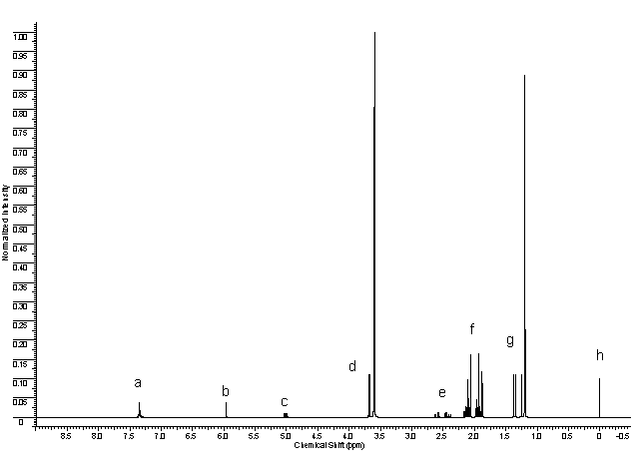

Problem 26. IONIC POLYMERIZATION

Polymerization may be initiated by ionic species. Depending on the charge on the end group of a propagating chain, cationic and anionic polymerization types are distinguished. Ionic as well as radical polymerization involves the stages of initiation, propagation, termination and chain transfer. Cationic polymerization is initiated by strong acids and other electrophilic compounds, whereas anionic by strong bases and electron donors.

1. For each monomer given below, choose polymerization type(s) (radical, anionic, cationic) which it can be involved in.

Anionic polymerization initiated by metal alkyls can be described by the following kinetic scheme, which includes stages of initiation, chain propagation and chain termination. The latter occurs as a result of carbanion reaction with a terminating agent, acid HA.

2. a) Write down the rate equation for monomer consumption, expressing concentrations of monomer and active chains (macroanions) as [M] and [M–], respectively.

b) Anionic polymerization allows synthesis of nearly monodisperse polymer. Based on this fact, compare qualitatively rate constants of initiation and chain propagation.

c) Calculate molecular mass of the polymer obtained as a result of polymerization of 100 g of styrene in 600 ml of 1,4-dioxane in the presence of 0.234 g of naphthalene and 0.042 g of metallic sodium, if 58.9% of the monomer was consumed during polymerization.

Polymerization is a perspective approach towards design of chain molecules of various shape and size. Still chain termination can be regarded as a drawback of the method, since it leads to species not capable of attaching new monomer units.

3. a) What chain termination processes are probable for radical and anionic polymerization? Fill in the table.

Type of chain termination | Radical polymerization | Anionic polymerization
Disproportionation
Recombination
Chain transfer to solvent
Chain transfer to monomer

b) Explain why a polymer obtained by anionic polymerization has narrower molecular mass distribution than that obtained by radical polymerization.

c) The following solvents are used as a medium for anionic polymerization: (a) benzene; (b) 1,4-dioxane; (c) tetrahydrofuran; (d) 1,2-dimethoxyethane. Arrange the solvents in the order of increasing polymerization rate.

d) Compare the rates of anionic polymerization with sodium, potassium and cesium naphthalenides used as initiators.

Problem 27. CO-POLYMERIZATION

To synthesize macromolecules with complex architecture one can use various approaches: apply different types of polymerization, vary initiators, solvents and reaction conditions, copolymerize different monomers, as well as modify the obtained polymers. Some examples of copolymers are given in the table hereunder.
Type of a copolymer | Schematic structure | Abbreviation
Block | AAAAAAAAAAAABBBBBBBBBBBBBB | poly(A)-block-poly(B)
Alternating | ABABABABABABABAB | poly(A-alt-B),  poly(AB)
Statistical | AABABAABBBAABBBABAABABAAB | poly(A-stat-B)
Graft |  | poly(A)-graft-poly(B)
Gradient | AAAAABAAABAABBABABBBBABBBB | poly(A-grad-B)

While developing copolymerization technique it is important to take into account relative reactivity of monomers. Kinetics of copolymerization can be described by a set of elementary reactions with corresponding rate constants. In the case of binary radical copolymerization four elementary reactions of chain propagation should be considered (end-unit model):

Relative reactivity of monomers in copolymerization is characterized by the ratio of the rate constants of their addition to a given macroradical: , and . These ratios are referred to as copolymerization constants (r value is always between zero and unity). For instance, for styrene and maleic acid anhydride the copolymerization constants are 0.04 and 0.01, respectively. Sometimes, the same approach is applied to define constants of binary ionic copolymerization.

1. Complete equations of polymerization reactions below and draw structures of compounds X₁ – X₇. Give both detailed and short formulas of all copolymers. In short formulas represent styrene units as St, ethylene oxide units as EO, vinyl alcohol units as VA, and maleic anhydride units as MA. Use abbreviations from the above table when necessary.

a)

b)
c)

2. Calculate the average length of a chain of units A in the polymer obtained by radical copolymerization of equimolar mixture of two monomers of the same reactivity.

Problem 28. TUNNELING IN CHEMISTRY

Tunneling through energy barriers is a purely quantum-mechanical effect. It is explained by the fact that wave functions can differ from zero even in the classically forbidden areas where energy of a particle is less than an energy barrier:
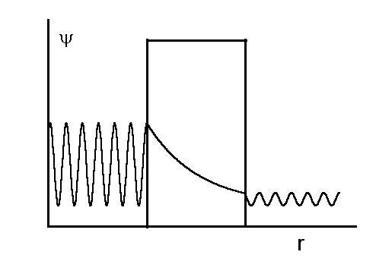

Inversion of ammonia is a widely known example of tunneling:

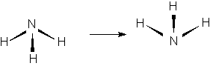

In this process the molecule of ammonia is turned out like an umbrella against a strong wind. The tunneling frequency is 24 GHz, and the energy barrier separating two states is 25 kJ/mol.

1. Draw the reaction energy profile (plot of energy vs. reaction coordinate) for the inversion of ammonia. What is the reaction coordinate? What coordinate corresponds to the maximum of energy?

2. In which region of the electromagnetic spectrum can the tunneling of ammonia be observed?

3. Find the energy difference corresponding to the tunneling frequency. What is the ratio of this energy to the barrier height?

4. How would the tunneling frequency change if we substitute some hydrogen atoms by deuterium ones? Explain.

Currently at the University of Pittsburgh, PA
This German word is not usually translated in English due to lack of adequate and short translations.

