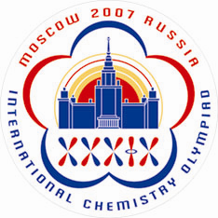 | Travel Details  (Form 3)
To be returned before June 1, 2007
Dr. Anna Bacheva
IChO-2007 Secretariat, Chemistry Department, Moscow State University
Leninskie Gory, 119992 Moscow, RUSSIA
Tel/Fax: +7 (495) 939-3185; E-mail: secretary@icho39.chem.msu.ru
Website: www.icho39.chem.msu.ru

1. | Country
2. | Number of persons
3. | Arrival
 | a) Names of arriving delegation members
 | b) Date and scheduled time
 | c) Airplane or train
 | d) Flight (train) No (if flight, indicate airline name)
 | e) Name of city and airport at origin
 | f) Name of airport (railway station) at destination
4. | Departure
 | a) Names of departing delegation members
 | b) Date and scheduled time
 | c) Airplane or train
 | d) Flight (train) No (if flight, indicate airline name)
 | e) Name airport (railway station) at origin
 | f) Name of city and airport at destination
5. | Early arrivals
 | a) number of persons
 | b) number of extra day
 | c) rooms required (indicate number and type: single, double, twin, triple, etc.)
6. | Late departures
 | a) number of persons
 | b) number of extra day
 | c) rooms required (indicate number and type: single, double, twin, triple, etc.)

Important!

This form may be returned to the IChO-2007 Organizers either by postal mail, or by fax, or by E-mail as an attached file. Alternatively you may pass through online registration at the IChO-2007 official website: www.icho39.chem.msu.ru

Payment for extra days accommodation to be made in cash on arrival to Moscow. Please feel free to contact secretary@icho39.chem.msu.ru for any questions.

If members of your delegation are not traveling in one group, please complete the need amount of Registration Forms 3 (one per group). For this purpose, you can either photocopy this form or download it from the IChO-2007 official website.

