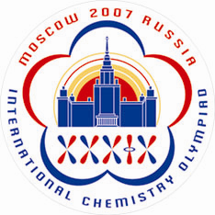 | Students Registration  (Form 2s)
To be returned before May 15, 2007
Dr. Anna Bacheva
IChO-2007 Secretariat, Chemistry Department, Moscow State University
Leninskie Gory, 119992 Moscow, RUSSIA
Tel/Fax: +7 (495) 939-3185; E-mail: secretary@icho39.chem.msu.ru
Website: www.icho39.chem.msu.ru
Country: ____________________________
 | Student # 1 | Student # 2 | Student # 3 | Student # 4
1. Family Name
2. First and Intermediate Names
3. Gender
4a. Date of Birth
4b. Country of birth
4c. Place of birth
5a. Citizenship on birth
5b. Present citizenship (name all if more than one)
6a. School
6b. School address
6c. School Telephone number*
6d. School Fax number*
6e. Date of graduation
7. Student’s E-mail
8a. Home address
8b. Private telephone number*
9. Emergency Contact Number*
10a. Passport Number
10b. Issued at
10c. Date of issue
10d. Valid until
11. Special Dietary Needs
12. Other Special Needs
13. T-shirt size (S, M, L, XL, XXL, XXXL)
* country code, area code, number
Important!
This form may be returned to the IChO-2007 Organizers either by postal mail, or by fax, or by E-mail as an attached file. Alternatively you may pass through online registration at the IChO-2007 official website: www.icho39.chem.msu.ru

