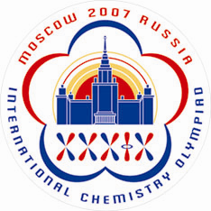 | Scientific Observer and Guest Registration  (Form 2og)
To be returned before May 1, 2007
Dr. Anna Bacheva
IChO-2007 Secretariat, Chemistry Department, Moscow State University
Leninskie Gory, 119992 Moscow, RUSSIA
Tel/Fax: +7 (495) 939-3185; E-mail: secretary@icho39.chem.msu.ru
Website: www.icho39.chem.msu.ru

Country: ____________________________

 | Scientific observer | Guest
1. Family Name
2. First and Intermediate Names
3. Gender
4a. Date of Birth
4b. Country of birth
4c. Place of birth
5a. Citizenship on birth
5b. Present citizenship (name all if more than one)
6a. Organization
6b. Position
6c. Official Address
6d. Telephone number*
6e. Fax number*
6f. E-mail
7a. Home address
7b. Private telephone number*
8. Emergency Contact Number*
9a. Passport Number
9b. Issued at
9c. Date of issue
9d. Valid until
10. Special Dietary Needs
11. Other Special Needs
12. T-shirt size
(S, M, L, XL, XXL, XXXL)
* country code, area code, number
Important!
This form may be returned to the IChO-2007 Organizers either by postal mail, or by fax, or by E-mail as an attached file. Alternatively you may pass through online registration at the IChO-2007 official website: www.icho39.chem.msu.ru
Payment of the fees should be made by April 1, 2007. Explore the IChO-2007 official website for banking details. Please feel free to contact secretary@icho39.chem.msu.ru for any questions.
If you have got more than one guest in your delegation you can photocopy this form or download it from the IChO-2007 official website.

