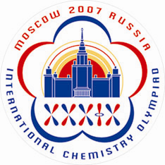 | Country Registration  (Form 1)
To be returned before March 1, 2007
Dr. Anna Bacheva
IChO-2007 Secretariat, Chemistry Department, Moscow State University
Leninskie Gory, 119992 Moscow, RUSSIA
Tel/Fax: +7 (495) 939-3185; E-mail: secretary@icho39.chem.msu.ru
Website: www.icho39.chem.msu.ru

1. | Country
2. | Contact person
 | a) Family Name
 | b) First and Intermediate Names
 | c) Postal address
 | d) Tel. (incl. country and area codes)
 | e) Fax. (incl. country and area codes)
 | f) E-mail
3. | Country participation fee
 | a) Number of years since the first participation or last being the host (which is smaller)
 | b) Fee  (calculated as 100*N US$, N is taken from i. 3a) | $
4. | Delegation
 | a) number of mentors (max. 2)
 | b) number of students (max. 4)
 | c) number of scientific observers (max. 1)
 | d) fee for scientific observer (1500 US$) | $
 | e) number of guests (no limit)
 | f) fee for guests  (calculated as 3000*M US$, M is taken from i. 4e) | $
5. | Total participation fee (3b+4d+4f) | $
6. | Examination language  (indicate the language(s) in which your students will write their exams)
7. | Necessity for installation of your own software (Yes/No)
8. | Your comments

Important!

This form may be returned to the IChO-2007 Organizers either by postal mail, or by fax, or by E-mail as an attached file. Alternatively you may pass through online registration at the IChO-2007 official website: www.icho39.chem.msu.ru

Payment of all fees should be made by May 1, 2007. Explore the IChO-2007 official website for banking details. Please feel free to contact secretary@icho39.chem.msu.ru for any questions.

If installation of your own software is needed, it must be sent to the Organizers by April 15, 2007.

