CHEMISTRY: ART, SCIENCE, FUN

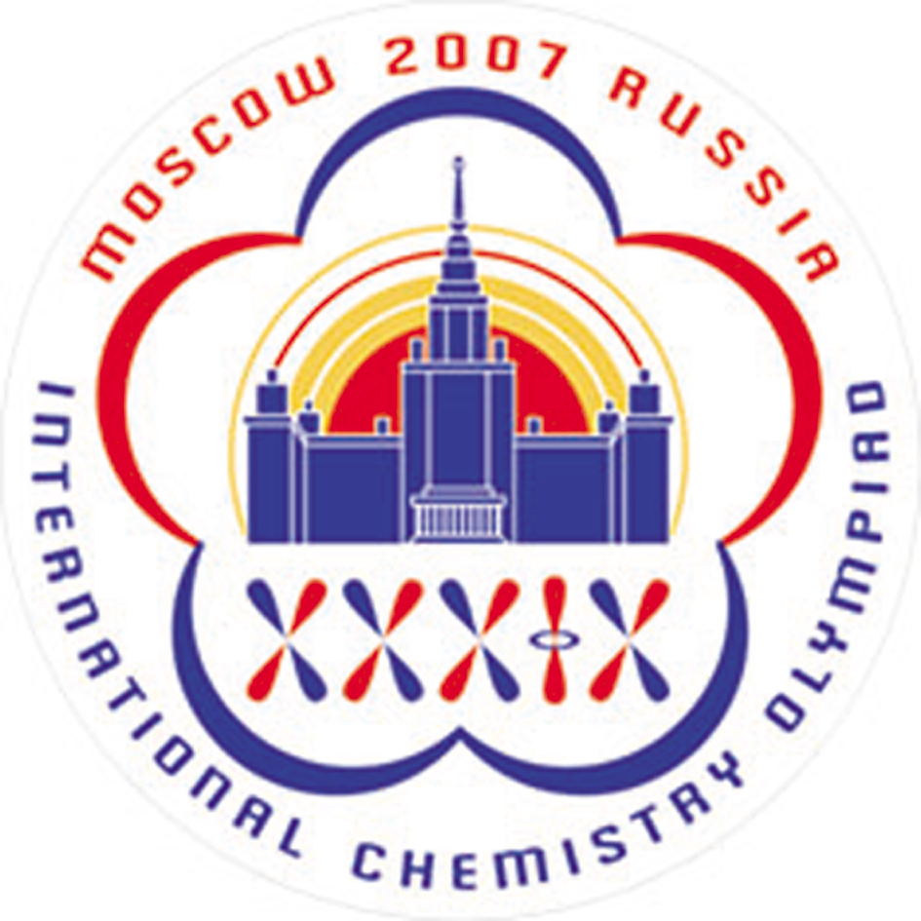

THEORETICAL EXAMINATION
PROBLEMS

JULY 20, 2007
MOSCOW, RUSSIA

24848 characters in Problems and Answer Sheets
General Directions

- Write your name and code number on each page of the answer sheet.

- You have 5 hours to fulfil the task. Failure to stop after the STOP command may result in zero points for the task.

- Write answers and calculations within the designated box.

- Use only the pen and the calculator provided.

- There are 18 pages of Problems (incl. Cover Sheet and Periodic Table) and 22 pages of Answer Sheet.

- An English-language version is available.

- You may go to the restroom with permission.

- After finishing the examination, place all sheets including Problems and Answer Sheet in the envelope and seal.

- Remain seated until instructed to leave the room.

Constants and useful formulas
Gas constant R = 8.314 J⋅K^{–1}⋅mol^{–1}
Avogadro constant N_{A} = 6.022∙10²³ mol^{–1}
Planck constants h = 6.626∙10^{–34} J⋅s
= 1.055∙10^{–34} J⋅s
Speed of light c = 3.00∙10⁸ m⋅s^{–1}

Uncertainty relation
Gibbs energy of a condensed phase at pressure p | G = pV + const
Excess pressure caused by surface tension | ΔP_{in} = 2σ / r
Relation between equilibrium constant and Gibbs energy
Gibbs energy at constant temperature
Isotherm of a chemical reaction | ΔG = ΔG° + RT∙ln Q  with Q =
Arrhenius equation
Osmotic pressure of a solution | p = cRT
Beer- Lambert law | A = log$\frac{P_{0}}{P}$ = εlc

V(cylinder) = πr²h
S(sphere) = 4πr²
V(sphere) = $\frac{4}{3}$πr³

Problem 1. Proton tunneling

Proton tunneling through energy barriers is an important effect, which can be observed in many complex species containing hydrogen bonds (DNA, proteins, etc.). Propanedial (malonaldehyde) is one of the simplest molecules for which intramolecular proton transfer can occur.

1.1.1 Draw the condensed formula of propanedial and the structures of two of its isomers, which can exist in equilibrium with propanedial.

1.1.2 In a water solution propanedial is a weak acid, its strength being comparable with that of acetic acid. Specify the acidic hydrogen atom. Explain its acidity (choose one version in the Answer Sheet).

On the plot below an energy profile of the intramolecular proton transfer is given (the dependence of energy on the distance of proton motion (in nm)). Energy curve has a symmetric double-well form.
1.2.1 Draw the structures corresponding to two minima on this curve.

A proton is delocalized between two atoms and oscillates between two minima L and R with an angular frequency ω = 6.48⋅10¹¹ s^{–1}. Probability density for a proton depends on time as follows:
,
wavefunctions and describe a proton localized in the left and right wells, respectively:

1.3.1 Write down the expressions for the probability density at three moments: (a) t = 0, (b) t = π/(2ω), (c) t = π/ω. Sketch the graphs of these three functions.
1.3.2 Without calculations, determine the probability of finding the proton in the left well at t = π/(2ω)
1.3.3 How much time is required for a proton to move from one well to another? What is the proton mean speed during the transfer?
1.3.4 From the energy curve, estimate the uncertainty of the position of proton forming hydrogen bonds. Estimate the minimal uncertainty of the proton speed. Compare this value with that obtained in 1.3.3 and draw a conclusion about the proton tunneling (choose one of the versions in the Answer Sheet).

Problem 2. Nanochemistry

Metals of the iron subgroup are effective catalysts of hydrogenation of СО (Fischer-Тropsch reaction)
Catalyst (e.g. cobalt) is often used in the form of solid nanoparticles that have a spherical structure (fig.1). The reduction in size of the catalyst increases catalytic activity significantly. The unwanted side-reaction however involves the oxidation of the catalyst:

Solid cobalt oxide (bulk) is formed in the reaction vessel. This causes an irreversible loss of the catalyst’s mass. Solid cobalt oxide can also be deposited on the surface of Co(s). In this case the new spherical layer is formed around the surface of the catalyst (see figure 2) and the catalytic activity drops.
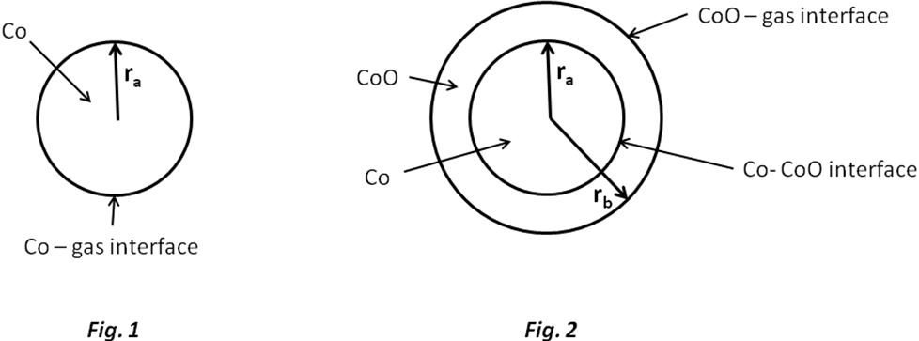

Let us see how formation of nanoparticles affects the equilibrium of reaction (1). Useful equation:
2.1.1 Calculate the standard Gibbs energy and the equilibrium constant for the reaction (1) at T = 500 K.
    - Calculate the equilibrium constant for reaction (1) when the cobalt catalyst is dispersed in the form of spherical particles (Fig.1) of radius
(a) 10^{–8} m,⋅
(b) 10^{–9} m.
The surface tension at the Co-gas interface is 0.16 J/m². CoO forms a bulk phase.

The mixture of gases involved in the Fischer-Tropsch reaction (CO, CН₄, Н₂, Н₂O) was put into a reaction vessel containing the cobalt catalyst. The total pressure is р = 1 bar, temperature is T = 500 K. The mole fraction of hydrogen (%) in the mixture is 0.15%.

2.2.1 At what minimum mole fraction of water (%) in the gas mixture the unwanted spontaneous oxidation of the catalyst becomes possible so that solid bulk CoO may appear in the system? Assume that cobalt catalyst is in the form of
(a) a bulk phase
(b) spherical nanoparticles with r_{a} = 1 nm (Fig. 1).

2.2.2 What would you suggest to protect Co nanoparticles from the spontaneous oxidation with the formation of bulk CoO at a constant ratio and a constant temperature:
(a) to increase r_{a};
(b) to decrease r_{a};
(c) change of r_{a} has no effect.

Assume now that solid cobalt oxide forms a spherical layer around a nanoparticle of cobalt. In this case the nanoparticle contains both a reactant (Co) and a product (CoO) (fig. 2).
In the following problems denote surface tensions as σ_{CoO-gas}, σ_{CoO-Co}, radii as r_{a}, r_{b}, molar volumes as V(Co); V(CoO).

2.3.1 Write down the expression for the standard molar Gibbs function of CoO.

2.3.2 Write down the expression for the standard molar Gibbs function of Co.

Hint. If two spherical interfaces surround a nanoparticle, the excess pressure at its centre is given by the expression
r_{i}, σ_{i} are radius and surface tension at the spherical interface i, respectively.

2.3.3 Express the standard Gibbs energy of the reaction (1) in terms of σ_{CoO-gas}, σ_{CoO-Co}, r_{a}, r_{b}, V(Co); V(CoO) and .

2.3.4 When spontaneous oxidation of Co begins the radii of two layers in the nanoparticle (Fig. 2) are almost equal, r_{a} = r_{b} = r₀, and . Assume that . Which plot in the Answer Sheet describes correctly the dependence of on ?

2.3.5 What would you choose to protect Co nanoparticles from the spontaneous formation of the external layer of CoO at a constant ratio and a constant temperature:
a) increase
b) decrease
c) change of r₀ has no effect.

Reference data:
Substance | ρ, g/cm³ | , kJ/mol
Co (s) | 8.90
CoO (s) | 5.68 | –198.4
H₂O (gas) |  | –219.1

Problem 3. Unstable chemical reactions
Many chemical reactions display unstable kinetic behavior. At different conditions (concentrations and temperature) such reactions can proceed in various modes: stable, oscillatory or chaotic. Most of these reactions include autocatalytic elementary steps.

Consider a simple reaction mechanism involving autocatalytic step:
(В and D are reagents, X is an intermediate and P is a product).

3.1.1 Write down the overall reaction equation for this two-step mechanism. Write the rate equation for X.

3.1.2 Deduce a rate equation using steady-state approximation. Find the orders:
(i) a partial reaction order with respect to B;
(ii) a partial reaction order with respect to D;
(iii) the overall order of a reaction.

Let the reaction occur in an open system where reagents B and D are being continuously added to the mixture so that their concentrations are maintained constant and equal: [B] = [D] = const.

3.2.1 Without solving the kinetic equation draw the kinetic curve [X](t) for the cases: 1) [X]₀ > k₂/k₁; 2) [X]₀ < k₂/k₁.

3.2.2 Without solving the kinetic equation draw the kinetic curve [X](t) for the case when the reaction proceeds in a closed vessel with the initial concentrations: [B]₀ = [D]₀, [X]₀ > k₂/k₁.

Much more complex kinetic behavior is possible for the reactions with several intermediates. Consider a simplified reaction mechanism for cold burning of ethane in oxygen:
Under specific conditions this reaction displays oscillatory behavior.

Intermediates are peroxide C₂H₆O₂ and aldehyde C₂H₄O, P is a stable product.

3.3.1 Identify X, Y, and P. Fill the blanks in the reaction mechanism.

Behavior of unstable reactions is often controlled by temperature which affects the rate constants. In the above oxidation mechanism oscillations of concentrations are possible only if k₁ ≥ k₂. Parameters of the Arrhenius equations were determined experimentally:
Step | A, cm³⋅mol^{–1}⋅s^{–1} | E_{A}, kJ⋅mol^{–1}
1 | 1.0⋅10¹¹ | 90
2 | 3.0⋅10¹² | 100
3.4.1 What is the highest temperature at which oscillatory regime is possible? Show your calculations.

Problem 4. Determination of water by Fischer titration

Determination of water by the classical Fischer method involves titration of a sample solution (or suspension) in methanol by a methanolic iodine solution, containing also an excess of SO₂ and pyridine (C₅H₅N, Py) – Fischer reagent. The following reactions occur during the titration:

SO₂ + CH₃OH + H₂O + I₂ = 2HI + CH₃OSO₃H
Py + HI = PyH⁺I⁻
Py + CH₃OSO₃H = PyH⁺CH₃OSO₃⁻

Iodine content is usually expressed in mg of water reacting with 1 mL of the titrant solution (hereunder T, mg/mL), which equals the mass of water (mg) reacting with 1.00 mL of the iodine solution. T is determined experimentally by titration of a sample with a known water content. The sample may be, for example, a hydrated compound or a standard solution of water in methanol. In the latter case it should be taken into account that methanol itself can contain certain amount of water.
In all calculations please use the atomic masses accurate to 2 decimal points.

4.1. Sometimes titration of water is performed in pyridine medium without methanol. How would the reaction of I₂ with SO₂ and H₂O occur in this case? Write down balanced reaction equation.

Calculate the T values of iodine solution in each of the following cases:

4.2.1. 12.20 mL of Fischer reagent solution were used for titration of 1.352 g of sodium tartrate dihydrate Na₂C₄H₄O₆.2H₂O.

4.2.2. A known amount of water (21.537 g) was placed into a 1.000 L volumetric flask which was filled by methanol up to the mark. For titration of 10.00 mL of the obtained solution, 22.70 mL of Fischer reagent solution were needed, whereas 2.20 mL of Fisher regent solution were used for titration of 25.00 mL of methanol.

4.2.3. 5.624 g of water were diluted by methanol up to a total volume of 1.000 L (solution A); 22.45 mL of this solution were used for titration of 15.00 mL of a Fischer reagent (solution B).
Then 25.00 mL of methanol (of the same batch as used for the preparation of solution A) and 10.00 mL of solution B were mixed, and the mixture was titrated by the solution A. 10.79 mL of the latter solution were spent.

4.3. An inexperienced analyst tried to determine water content in a sample of CaO using Fischer reagent. Write down the equation(s) of reaction(s) demonstrating possible sources of errors.

For the titration of 0.6387 g of a hydrated compound Fe₂(SO₄)₃·xH₂O, 10.59 mL of iodine solution (T = 15.46 mg/mL) were consumed.

4.4.1. What other reaction(s), beside those given in the problem, can occur during the titration? Write down the equations of two such processes.

4.4.2. Write down an equation of the overall reaction of Fe₂(SO₄)₃·xH₂O with the Fischer reagent.

4.4.3. Calculate the composition of the hydrate Fe₂(SO₄)₃·xH₂O (x = integer).

Problem 5. A mysterious mixture (organic hide-and-seek game)

An equimolar mixture X of three colorless organic liquids A, B, C was treated by water with a drop of hydrochloric acid at heating to give, after separation from water, a 1:2 (molar ratio) mixture of acetic acid and ethanol without any other components. To the mixture after hydrolysis a catalytic amount (one-two drops) of concentrated sulfuric acid was added, and after long reflux (boiling with reflux condenser) a compound D, a volatile liquid with pleasant smell, was formed in 85% yield. Compound D is not identical to any of A, B, C.
5.1.1 Draw the structure of compound D?
5.1.2 Which class of organic compounds does D belong to? Choose the proper variant from those given in the Answer Sheet.
5.1.3 Even if the reflux is continued twice as long, the yield of D would not exceed 85%. Calculate the expected yield of D if 1:1 (molar ratio) mixture of ethanol and acetic acid is taken. Assume that: a) volumes do not change during the reactions; b) all concomitant factors, such as solvent effects, non-additivity of volumes, variation of temperature, etc. are negligible. If you cannot make a quantitative estimate, please indicate whether the yield will be: a) the same (85%); b) higher than 85%; c) lower than 85%.

¹H NMR spectra of compounds A, B, C look very similar and each shows singlet, triplet and quartet with the ratio of integral intensities equal to 1:3:2.

The same mixture X was subjected to alkaline hydrolysis. A remained unchanged, and was separated. The remaining solution after acidification and short boiling gave 2:3 (molar ratio) mixture of acetic acid and ethanol with evolution of gas.

The mixture X (3.92 g) was dissolved in diethyl ether and underwent hydrogenation in the presence of Pd on charcoal catalyst. 0.448 L (standard conditions) of hydrogen were absorbed, but after the reaction A and C were isolated unchanged (3.22 g of mixture were recovered) while neither B, nor any other organic compounds except diethyl ether could be identified after hydrogenation.

5.2.1 Determine and draw the structures of A, B, and C.
5.2.2 Which intermediate compounds are formed during the acidic hydrolysis of C, and basic hydrolysis of B.

The reaction of either B or C with acetone (in the presence of a base) with subsequent acidification by dilute HCl at gentle heating gives the same product, senecioic acid (SA), a compound widely occurring in Nature. Alternatively, senecioic acid can be obtained from acetone by treating it with concentrated HCl and subsequent oxidation of the intermediate product by iodine in alkaline solution. The latter reaction gives, besides sodium salt of senecioic acid, a heavy yellow precipitate E (see the scheme 2).

5.3.1 Determine the structure of senecioic acid and draw the reaction scheme leading to SA sodium salt from acetone.

5.3.2 Give structure of E.

Problem 6. Silicates as the base of the Earth crust

Silica and compounds derived from it, silicates, constitute ca. 90 % of the Earth crust substances. Silica gives rise to a beautiful material – glass. Nobody knows exactly how glass was discovered. There is a well-favored story related to Phoenician sailors who fused occasionally sea sand and soda ash. It is likely that they discovered the secret of “liquid glass” (LGL) – sodium metasilicate (Na₂SiO₃) soluble in water.
6.1.1 The solution of LGL was used earlier as office glue. Write down the net ionic equation accounting for the ability of LGL to set in air.

Hydrolysis of LGL in water allows obtaining a colloidal solution of silicic acid.
6.1.2. Complete the Table in the Answer Sheet. Write down the net ionic equations matching the processes enumerated in the Table. For each process check the “Yes” box if it leads to changes of pH. Otherwise check the “No” box.
The structure of species occurring in aqueous solutions of silicates is rather complex. However, it is possible to distinguish the main building block of all species – orthosilicate tetrahedron (SiO₄⁴⁻, 1):
(1)
For [Si₃O₉]^{n-} ion found in aqueous solution of silicates:
6.2.1 Determine the charge (n).
6.2.2 Determine the number of oxygen atoms bridging adjacent tetrahedra.
6.2.3 Depict its structure joining together several tetrahedra (1). Take into account that any adjacent tetrahedron shares one vertex.

Charged monolayers with the composition [Si₄O₁₀]^{m-} are found in kaolinite (clay).
6.2.4 Using the same strategy as in 6.2.1-6.2.3, depict a fragment of the layered structure joining 16 tetrahedra (1). Note that 10 tetrahedra have shared vertices with 2 neighbors each, and the rest 6 have shared vertices with 3 neighbors each.

Being placed into the LGL solution, salts of transition metals give rise to fancy “trees” tinted relevant to the color of the salt of the corresponding transition metal. Crystals of CuSO₄·5H₂O produce “trees” of blue color, whereas those of NiSO₄·7H₂O form green “trees”.
6.3.1 Determine the pH of 0.1 M aqueous solution of copper sulfate at 25°С, assuming that its hydrolysis occurs in small degree only. Use the value of the first acidity constant of [Cu(H₂O)₄]²⁺ K_{a}^{I}=1·10⁻⁷ M.
6.3.2 Write down equation of a reaction between aqueous solutions of CuSO₄ and sodium metasilicate (LGL). Take into account the pH values of aqueous solutions of the salts.

Problem 7. Atherosclerosis and intermediates of cholesterol biosynthesis

Cholesterol is a lipid wide-spread in living nature. Disruption of its metabolism leads to atherosclerosis and related potentially fatal diseases.

Substances Х and Y are two key intermediates of cholesterol biosynthesis in animals.

Х is an optically active monocarbonic acid composed of atoms of only three elements. It is formed in organisms from (S)-3-hydroxy-3-methylpentanedioyl-coenzyme A (HMG-CоА). This reaction is catalyzed by enzyme Е1 (which catalyses two types of reactions) and does not involve water as a substrate. Х is further metabolized into Х1 through a three-stage process requiring enzymes E2, E3, E4, which catalyze reactions of one and the same (and only one) type. Finally, Х1 spontaneously (non-enzymatically) decomposes to give isopentenyl pyrophosphate (3-methylbut-3-enyl diphosphate, IPP) and inorganic products:
7.1.1 In the Answer Sheet, choose the reaction type(s) for Е1 and Е3.
7.1.2 Draw the structure of X with stereochemical details and indicate absolute configuration (R or S) of the stereocenter.

Y is an unsaturated acyclic hydrocarbon. Its reductive ozonolysis leads to a mixture of only three organic substances Y1, Y2 and Y3 in a molar ratio of 2:4:1. Y is formed as a result of a number of successive coupling reactions of two isomeric substances: IPP and dimethyl allyl pyrophosphate (3-methylbut-2-enyl diphosphate, DAP) with subsequent reduction of a double bond in the final coupling product Y5. Carbon atoms IPP and DAP involved in the formation of C-C bonds during biosynthesis of Y are marked with asterisks.
7.2.1 Write down the overall reaction equation for reductive ozonolysis of DAP, if dimethyl sulfide is used as the reducing agent.

The product of the final coupling reaction (hydrocarbon Y5) is formed when two hydrocarbon residues (R) of intermediate Y4 are combined:

At each coupling stage but that shown in Scheme 2, pyrophosphate is released in a molar ratio of 1:1 to the coupling product.

7.2.2 Determine molecular formula of Y, if it is known that Y2 and Y3 contain 5 and 4 carbon atoms, respectively.
7.2.3 Calculate the number of IPP and DAP molecules needed to give Y5, if it is known that all carbon atoms of isomeric pyrophosphates are incorporated into Y.
7.2.4 Draw the product of coupling reaction of one IPP molecule with one DAP molecule (C-C bond can be formed only by carbon atoms marked with asterisks), if it is known that subsequent reductive ozonolysis of the product of the coupling reaction gives Y1, Y2 and one more product, the latter containing phosphorus.

The only double bond reduced in Y5 during its metabolism into Y was formed in the reaction described in Scheme 2. All double bonds in Y and Y4 exist in trans configuration.
7.2.5 Draw structures of Y and Y4 with stereochemical details.

Problem 8. ATRP allows new polymers

ATRP (Atom Transfer Radical Polymerization) is one of the most promising novel approaches towards polymer synthesis. This modification of radical polymerization is based on a redox reaction of organic halides with complexes of transition metals, Cu (I) in particular. The process can be described by the following scheme (M – monomer, Hal – halogen):
The reaction rate constants are:
k_{act} - all activation reactions, k_{deact} – all reversible deactivation reactions, k_{p} - chain propagation, and k_{t} - irreversible termination.

8.1.1 Write down expressions for the rates of ATRP elementary stages: activation (v_{act}), deactivation (v_{deact}), propagation (v_{p}) and termination (v_{t}). Write down generalized equation assuming just one reacting species R’X, where R’ means any of R- or R-M_{n}- and X means Hal.

Consider that the total number of polymeric chains is equal to that of initiator molecules. Assume that at each moment throughout polymerization all chains are of the same length.

8.1.2 Compare the rate of deactivation to the rates of ATRP elementary stages.

Dependence of monomer concentration ([M]) on reaction time (t) for ATRP is:
,
[M]₀ - initial monomer concentration, k_{p} – rate constant of propagation, [R∙] – concentration of active radicals.

To prepare a polymer sample by using ATRP, catalytic amounts of CuCl, organic ligand (L) and 31.0 mmol of monomer (methylmethacrylate, or MMA) were mixed. The reaction was initiated by adding 0.12 mmol of tosyl chloride (TsCl). Polymerization was conducted for 1400 s. k_{p} is 1616 L∙mol⁻¹s⁻¹, and the steady state concentration of radicals is 1.76∙10⁻⁷mol∙L⁻¹.

8.2.1 Calculate mass (m) of the polymer obtained.

In another experiment the time of MMA polymerization was changed, all the rest reaction conditions being the same. The mass of the obtained polymer was 0.73 g. Then 2-(trimethylsilyloxy)ethyl methacrylate, HEMA-TMS (23.7 mmol) was added to the mixture and polymerization was continued for another 1295 s. MMA and HEMA-TMS reactivities are the same under reaction conditions.
8.2.2 Calculate degree of polymerization (DP) of the obtained polymer.
8.2.3 Depict the structure of the obtained polymer (including end groups), showing MMA and HEMA-TMS units as A and B, respectively. If necessary, use the symbols in the copolymer structure representation: block (block), stat (statistical), alt (alternating), grad (gradient), graft (grafted). For example, (A₆₅-graft-C₁₀₀)-stat-B₃₄ means that chains of polymer C are grafted on units A in the statistic copolymer of A and B.

ATRP was applied to synthesize two block copolymers, P1 and P2. One block in both block-copolymers was the same and was synthesized from mono-(2-chloropropionyl)-polyethylene oxide used as a macroinitiator:

The other block in P1 consisted of styrene (C), and in P2 of p-chloromethylstyrene (D) units.

¹H NMR spectra of the macroinitiator, P1 and P2 are given below. Integral intensities of characteristic signals can be found in the table.

8.3.1 Assign ¹H NMR signals to substructures given in the Answer Sheet.
8.3.2 Determine molar fractions of units C and D and molecular weights of P1 and P2.
8.3.3 Write down all possible reactions of activation occurring during the synthesis of P1 and P2. You may use R symbol to depict any unchanged part of the macromolecule, but you should specify what substructure you use it for.
8.3.4 Draw the structure of P1 and one of possible structures of P2 representing poly(ethylene oxide) chain by a wavy line and showing units of co-monomers as C and D, respectively.
