CHEMISTRY: ART, SCIENCE, FUN

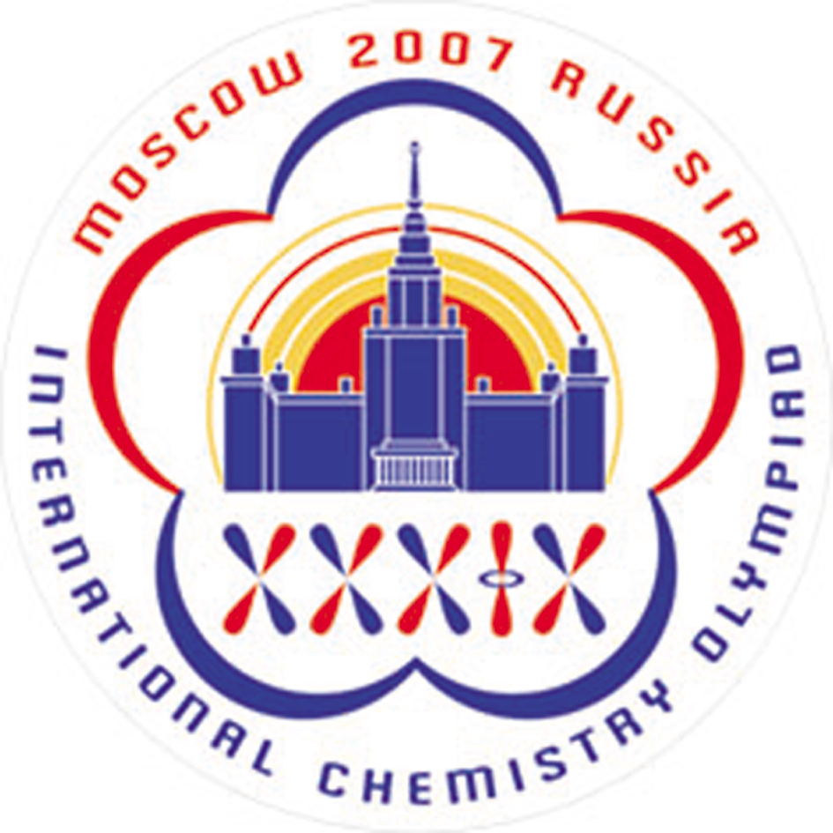

THEORETICAL EXAMINATION
ANSWER SHEETS

JULY 20, 2007
MOSCOW, RUSSIA
1.1.1 Structures:
Propanedial

1st isomer

2nd isomer

1.1.2 Circle the acidic hydrogen atom

The acidity of propanedial is caused by
- the stability of a carbanion due to conjugation with two carbonyl groups
- weakness of C–H bond in a carbonyl group
- hydrogen bonds between two propanedial molecules

The correct answer _______

1.2.1 The structures corresponding to minima on energy curve:

1.3.1 The probability density
(a) t = 0

(b) t = π/(2ω)

(c) t = π/ω

1.3.2
The probability of finding the proton in the left well = _______

1.3.3 The time of proton transfer
Your work:

t =

The proton mean speed
Your work:

v =

1.3.4 The uncertainty of proton position
Δx =

The minimal uncertainty of proton velocity
Your work:

Δv =

- Proton is a rather heavy particle, and its tunneling in malonaldehyde can be described in classical terms of position and velocity
- Proton tunneling is a purely quantum effect; it cannot be described in classical terms
- Uncertainty of proton velocity is so large that tunneling cannot be observed experimentally
- Uncertainty of proton velocity is so small that tunneling cannot be observed experimentally

The correct answer is _______

2.1.1 Thermodynamic data for the reaction (1):
Your work:

Δ_{r}G⁰ (1) =

K =

2.1.2 Equilibrium constant for the reaction (1) with cobalt nanoparticles:
Your work:

(a) K (r = 10^{–8} m) = (b) K (r = 10^{–9} m) =
2.2.1 Minimum water content in the mixture:
Your work:

(a) H₂O%(bulk Co) =

(b) H₂O%(nanoparticles with r = 1⋅10^{–9} m) =

    - The correct answer is (mark the proper box):

(a) (b) (c)

2.3.1 Standard molar Gibbs function of CoO (external layer)

=

    - Standard molar Gibbs function of Co (internal layer):

=

2.3.3 Standard Gibbs energy for the reaction (1) with the double-layered nanoparticles

=

2.3.4. Plot Δ_{r}G⁰ (1,r₀) vs. r₀
The correct plot is (mark the proper box):

(a) (b) (c) (d)

    - The correct answer is (mark the proper box):

(a) (b) (c)

3.1.1 The overall reaction equation

The kinetic equation for X

3.1.2 The rate equation
Your work:

Reaction orders:

with respect to B (i): ______

with respect to D (ii): ______

overall (iii): ______

3.2.1 1) An open system, [X]₀ > k₂/k₁

2) An open system, [X]₀ < k₂/k₁

3.2.2 A closed system, [B]₀ = [D]₀, [X]₀ > k₂/k₁

3.3.1

X –

Y –

P –

3.4.1 The highest possible temperature:

Your work:

T =

4.1. Equation:

4.2.1. Calculation of the T value:
Your work:

T = _______________ mg/mL

4.2.2. Calculation of the T value:
Your work:

T = _______________ mg/mL

4.2.3. Calculation of the T value:
Your work:

T = _______________ mg/mL

4.3. Equation(s):

4.4.1 Equation(s):

4.4.2. Equation:

4.4.3. The composition of the crystallohydrate is:
Your work:

Formula of the salt Fe₂(SO₄)₃·xH₂O: x = _____________

5.1.1 Structure of product D

5.1.2 Which class of organic compounds does D belong to? Check the appropriate box.
Note! Only one checkmark is allowed. Several checkmarks will lead to 0 marks for this question.
ketones | ethers | acetals | esters | alcohols | aldehydes | glycols
□ | □ | □ | □ | □ | □ | □

5.1.3 The expected yield of D
The yield is equal to 85% □; lower than 85% □; greater than 85% □

Your work:

yield = %

5.2.1 The structures of A, B, and C.
A | B | C

5.2.2 Draw in the boxes intermediate compounds formed during the acidic hydrolysis of C, and basic hydrolysis of B.
5.3.1 The structure of senecioic acid and the reaction scheme leading to SA sodium salt from acetone.

5.3.2 The structure of E.

6.1.1 The net ionic equation accounting for the ability of LGL to set in air

6.1.2 Write down the net ionic equations matching the processes enumerated in the Table. For each process check the “Yes” box if it leads to changes of pH. Otherwise check the “No” box.
а) protonation of ortho-silicate ions leading to the formation of Si-OH groups
Reaction equation: | Yes | No
b) formation of hydrated [SiO₄(H₂O)₂]⁴⁻ anions
Reaction equation: | Yes | No
c) polycondensation of ortho-silicate ions leading to the formation of Si-O-Si bonds
Reaction equation: | Yes | No

6.2 For [Si₃O₉]^{n-} ion found in aqueous solution of silicates:
6.2.1 Determine the charge (n).
Your justification

n = ______
6.2.2 Determine the number of oxygen atoms bridging adjacent tetrahedra.
Your justification

Number of oxygen atoms = ______

6.2.3 Depict the ion structure joining together several tetrahedra (1).

6.2.4 The fragment of the layered structure joining 16 tetrahedra (1)
Your justification

Structure

6.3.1 pH of 0.1 M aqueous solution of copper sulfate
Your justification

pH = _______

6.3.2 Equation of a reaction between aqueous solutions of CuSO₄ and sodium metasilicate (LGL)

7.1.1 A number of reaction types is listed in the table below. All reactions involved in metabolism of HMG-CoA to IPP are in the list. Choose those types of reactions which are catalyzed by Е1 and Е3 (put numbers in appropriate places).
No | Reaction type
1. | Dehydration
2. | Decarboxylation
3. | Dephosphorylation
4. | 4 electron reduction
5. | Release of the reduced form of coenzyme A (CoA-SH)
6. | Monophosphorylation
7. | Oxidation of hydroxyl group as the third stage of HMG-CoA β-oxidation cycle

Е1 | _______________
Е3 | _______________

7.1.2 Draw the structure of X with stereochemical details and indicate absolute configuration (R or S) of the stereocenter.

7.2.1 Write down the overall reaction equation for reductive ozonolysis of DAP with dimethyl sulfide used as the reducing agent.

7.2.2 Determine molecular formula of Y.

Your justification

Number of carbon atoms_______

Number of hydrogen atoms_____ Molecular formula:________________
7.2.3 Calculate the number of IPP and DAP molecules needed to give Y5.
Your justification:

Number of IPP molecules ____ Number of DAP molecules ____

7.2.4 Draw the product of coupling reaction between one IPP molecule and one DAP molecule, subsequent reductive ozonolysis of which gives Y1, Y2 and one more product, the latter containing phosphorus.

7.2.5 Draw the structures of Y and Y4 with stereochemical details.
Y4
Y

8.1.1 Expressions for the rates:
v_{act} = | v_{p} =
v_{deact} = | v_{t} =

8.1.2 Compare rates using operators <<, ≤, ≈, ≥, >>
v_{deact} v_{act} | v_{deact} v_{t}
v_{deact} v_{p}

8.2.1 Mass of the obtained polymer.
Your justification:

m =
8.2.2 Degree of polymerization of the obtained polymer.
Your justification:

DP =

8.2.3 Structure of the obtained polymer.
8.3.1 Fill in the right column with symbols (a-g) of ¹H NMR signals corresponding to substructures in the left column.

8.3.2 Composition and molecular weights of copolymers P1 and P2.
Your justification:  n(C) = n(D) = | Your justification:  M(P1) = M(P2) =
8.3.3. All possible reactions of activation
P1:

P2:

8.3.4 Structure of P1 and one of possible structures of P2
P1: | P2:

