CHEMISTRY: ART, SCIENCE, FUN

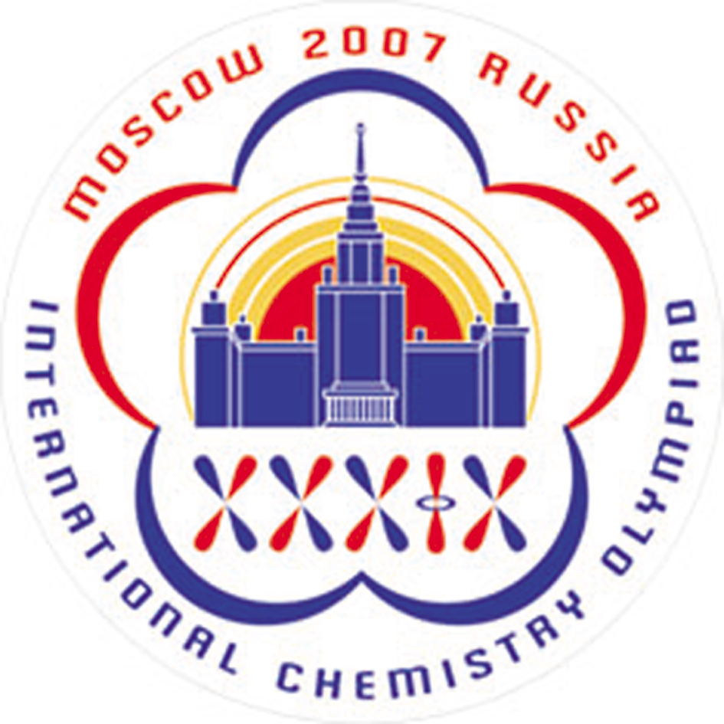

PRACTICAL EXAMINATION

Solution and
GRADING SCHEME

JULY 18, 2007
MOSCOW, RUSSIA

Problem 1. Ion-exchange chromatography of amino acids.

1.1a 3 marks for each peak if at least two blank wells between peaks
9 marks maximum.

1.1b Not graded.

1.1.c 1 point for each proper choice. Combined mixtures should include all fractions identified as “2” and “3” and should be free of fractions without amino acids. Fractions identified as “1” may be or may be not included.
3 marks maximum.

1.2-1.3
Content of an amino acid = $\frac{A_{λ}⋅n⋅V⋅M_{W}}{ε⋅l}$,
A_{λ} is the absorbance of the sample calculated from the spectra, l is the optical length (1.0 cm), n is the dilution factor determined as a ratio of the aliquot of analyzing solution (0.1 mL) and the final volume of the sample in the cuvette, V is the volume of the combined fraction from the corresponding peak, and M_{W} is the molar mass of the amino acid.
3 marks for correct formula,
3 marks for correct determination of optical densities (1 mark for each assay)
1 mark penalty for miscalculation.

Content of each amino acid is determined by using the following plot (values recalculated from volumes reported by students and absorbance values recorded by spectrophotometer)

Scoring:
m < min m_{acc} OR m > max m_{acc} 0 marks
min m_{acc} < m < min m_{exp} $P_{\text{max}}\frac{(m−\text{min}m_{\text{acc}})}{(\text{min}m_{\text{exp}}−\text{min}m_{\text{acc}})}$ marks
min m_{exp} < m < max m_{acc} P_{max} marks

Amino acid | Min m_{acc}/m_{exact} ·100% | Min m_{exp}/m_{exact} ·100% | Max m_{exp}/m_{exact} ·100% | Max m_{acc}/m_{exact} ·100% | P_{max}
Cys | 70% | 85% | 110% | 115% | 22
His | 60% | 85% | 110% | 115% | 22
Arg | 25% | 45% | 65% | 85% | 22

72 marks maximum

1.4 As it is given in the task text, mixed disulfide and 2-thio-5-nitrobenzoic acid are formed in the reaction.

Under slightly alkaline conditions, thiol group of (II) dissociates, and thiophenolate-anion is formed. Resonance structures can be realized for this compound:
,
The electronic structure of asymmetrical disulfide (I) does not differ considerably from that of the original Ellmann reagent. Therefore, it can be concluded that the compound responsible for coloration is thiophenolate-anion (a form containing C=S bond).

2 marks for three correct ionized structures, one of which contains C=S bond
1 mark for three other structures, all without C=S bond
1 mark for less than three structures, one of which contains C=S bond.
2 marks maximum.
Problem 2. Determination of carbonate and hydrogen phosphate in an abrasive sample.

2.1a, 2.2, 2.3 The values of the final volumes V_{1,f}, V_{2,f}, and V_{3,f}, (as reported in the Answer Sheet) are graded according to the following scheme:
ΔV = |V_{reported} – V_{true}|,
V_{reported} is either V_{1,f}, V_{2,f}, and V_{3,f}, V_{true} is the corresponding master value (will be given with the copies of students’ works).

Value of ΔV | Marks
ΔV≤ΔV_{expected} | 25
ΔV≥ΔV_{acceptable} | 0
ΔV_{expected}≤ΔV≤ΔV_{acceptable} | $$\text{25}×\left(\frac{{ΔV}_{\text{acceptable}}−ΔV}{{ΔV}_{\text{acceptable}}−{ΔV}_{\text{exp}\text{ected}}}\right)$$

The values of ΔV_{expected} and ΔV_{acceptable} (in mL) are listed in the table below.
 | ΔV, mL
 | expected | acceptable
V_{1,f} | 0.10 | 0.25
V_{2,f} | 0.15 | 0.40
V_{3,f} | 0.15 | 0.40

25 marks maximum for each titration

2.1b Calculation of NaOH concentration
Your work
c(NaOH) = $\frac{c(\text{HCl})×V(\text{HCl})×V(\text{aliquot})}{V(\text{flask})×V(\text{NaOH})}$ = $\frac{1\text{.}\text{214} ({\text{mol}}/L)×\text{10}\text{.}\text{00}(\text{mL})×\text{10}\text{.}\text{00}(\text{mL})}{\text{100}\text{.}0(\text{mL})×V_{1,f}(\text{mL})}$ =
=

с(NaOH) = __________ mol/L

2.4 Calculation of the mass of CO₃²⁻
Your work
m(CO₃²⁻) (g) =
M(CO₃²⁻)×1/2×$\frac{c(\text{NaOH})×(V_{1,f}−V_{3,f})×V(\text{flask})}{V(\text{aliquot})}$ =
=60.01 (g/mol)×1/2×$\frac{c(\text{NaOH}) ({\text{mol}}/L)×(V_{1,f}−V_{3,f}) (\text{mL})×\text{100}\text{.}0 (\text{mL})}{\text{10}\text{.}\text{00} (\text{mL})}×0\text{.}\text{001} (L/{\text{mL}})$=
=

m(CO₃²⁻) = __________ g

2.5 Calculation of the mass of HPO₄²⁻
Your work
m(HPO₄²⁻) (g) =
= M(HPO₄²⁻)×$\frac{c(\text{NaOH})×(V_{3,f}−V_{2,f})×V(\text{flask})}{V(\text{aliquot})}$ =
= 95.98 (g/mol)×$\frac{c(\text{NaOH}) ({\text{mol}}/L)×(V_{3,f}−V_{2,f}) (\text{mL})×\text{100}\text{.}0 (\text{mL})}{\text{10}\text{.}\text{00} (\text{mL})}×0\text{.}\text{001} (L/{\text{mL}})$=
=

m(HPO₄²⁻) = __________ g

2.1b, 2.4, 2.5
Correctness of calculations is graded by:
1) comparing the numerical result (including the number of significant figures) reported by a student with that obtained from the student's data using correct method of calculation;
2) checking out the a student's way of calculation.

5 marks maximum for completely correct calculation of each value

Penalty for errors in calculations or data presentation.
 | Error type | Penalty marks (for calculation of each value)
1 | Incorrect method of calculation | -5
2 | Mistakes in dilution factor | -1
3 | Confusion between units of measurement | -1
4 | Mistake in stoichiometric (equivalency) relationships | -1
5 | More or less than 4 significant figures in c(NaOH) | -0.5*
6 | More than 4 or less than 3 significant figures in m(CO₃²⁻) and m(HPO₄²⁻) | -0.5*
7 | Rounding errors affecting the 1st or 2nd significant figures in the final result | -0.5**
8 | Miscalculations and slips | -0.2 per error

*Only the number of significant figures in the final answer is taken into account.
**Not applied if the error originates from insufficient number of significant figures in previously calculated c(NaOH). No double penalty!

2.6a
Ca²⁺ + H₂PO₄⁻ → CaHPO₄ + H⁺
or
3Ca²⁺ + 2HPO₄²⁻ → Ca₃(PO₄)₂ + 2H⁺

In course of these processes free protons evolve influencing the results of titration.
1 mark if the Answer Sheet contains at least one correct reaction equation. Incorrect equations are not penalized.

2.6b
Mistake | Error
Mistake | CO₃²⁻ content | HPO₄²⁻ content
Below pH 4.5 (first endpoint, V₂) H₂CO₃ is not titrated  Between pH 4.5 and 10 (second endpoint, V₃) H₂CO₃ is titrated  Thus, increase of V₃ ; V₁ and V₂ unchanged | - | +
No influence, C₂O₄²⁻ is too weak base | 0 | 0
Increase of V₁ and proportional decrease of c(NaOH) [as c(NaOH)V₁ is equivalent to the initial amount of standard HCl and so remains constant]; V₂ and V₃ unchanged | - | -
Losses of sample leads to proportional decrease of V₂ and V₃ and therefore V₃-V₂; V₁ unchanged | + | -
Increase of V₂, V₁ and V₃ unchanged | 0 | -
Increase of V₃, V₁ and V₂ unchanged | - | +

