CHEMISTRY: ART, SCIENCE, FUN

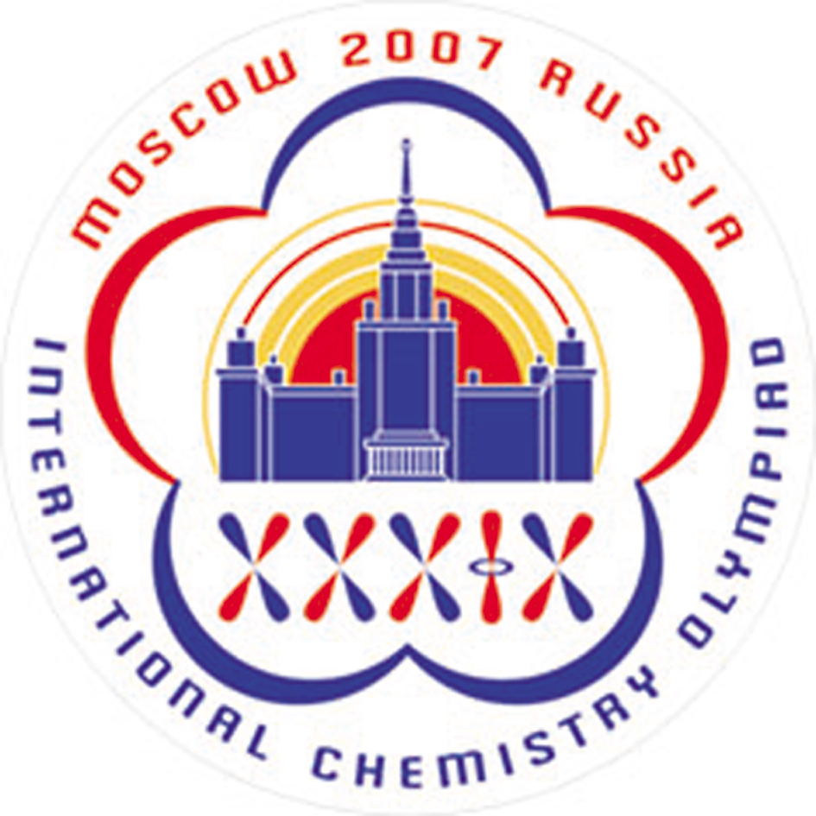

PRACTICAL EXAMINATION
ANSWER SHEETS

JULY 18, 2007
MOSCOW, RUSSIA
Number of the given mixture of amino acids ________ (A number between 301 and 600)

1.1a Draw the profile of coloration intensity on the plate sketch.
1.1b Indicate changes of eluents by drawing lines between the corresponding wells.
 | 1 | 2 | 3 | 4 | 5 | 6 | 7 | 8 | 9 | 10 | 11 | 12
A
B
C
D
E
F
G
H

1.1c Labels of wells corresponding to the chosen fractions.
Peak number | Labels of wells
1
2
3

1.2-1.3 Content (in mg) of each amino acid in the amino acid mixture you were given.
Your work

Complete the table.
Peak number | Volume of combined fractions, mL | Amino acid (3-letter code) | Wavelength λ, nm | Absorbance A_{λ} | Amino acid mass in the given mixture, mg
1
2
3

ATTENTION. The print-offs with the spectra of your samples should be put into the envelope and delivered at the end of examination alongside with the Answer Sheets.

1.4 Resonance structures of the substance responsible for the mixture coloration.

2.1a Standardization of NaOH solution
Titration No | Initial burette reading, mL | Final burette reading, mL | Volume of NaOH solution consumed (V₁), mL
1
2
3
Final volume of NaOH solution (V_{1,f}), mL

2.1b Calculation of NaOH concentration
Your work

с(NaOH) = __________ mol/L

2.2 The first titration of the sample (BCG)
Titration No | Initial burette reading, mL | Final burette reading, mL | Volume of NaOH solution consumed (V₂), mL
1
2
3
Final volume of NaOH solution (V_{2,f}), mL
2.3 The second titration of the sample (TP)
Titration No | Initial burette reading, mL | Final burette reading, mL | Volume of NaOH solution consumed (V₃), mL
1
2
3
Final volume of NaOH solution (V_{3,f}), mL
2.4 Calculation of the mass of CO₃²⁻
Your work

m(CO₃²⁻) = __________ g

2.5 Calculation of the mass of HPO₄²⁻
Your work

m(HPO₄²⁻) = __________ g

Additional questions
2.6a Indicate one reaction (write down the equation) for a process interfering in the sample analysis you have carried out in the presence of Ca²⁺.

2.6b A list of mistakes possible at different steps is given in the table. Indicate which of the mistakes can lead to errors in CO₃²⁻ and/or HPO₄²⁻ content determination. Use the following symbols: “0” if no error is expected, “+”or “–“ if the result is higher (positive error) or lower (negative error) than the true one.
Mistake | Step | Error
Mistake | Step | CO₃²⁻ content | HPO₄²⁻ content
Incomplete removal of CO₂ | 1
Too large excess of K₂C₂O₄ on calcium precipitation | 2
Too late indication of the endpoint (overtitration) on NaOH standardization | 3
Insufficient washing of the filter at CaC₂O₄ filtration | 4
Overtitration of the sample against BCG | 5
Overtitration of the sample against TP | 6
H₂CO₃: pK_{a1} = 6.35; pK_{a2} = 10.32
H₂C₂O₄: pK_{a1} = 1.25; pK_{a2} = 4.27

Extra samples given or column broken
Problem No | Sample No | Column broken and replaced | Student’s signature | Lab assistant’s signature

