CHEMISTRY: ART, SCIENCE, FUN

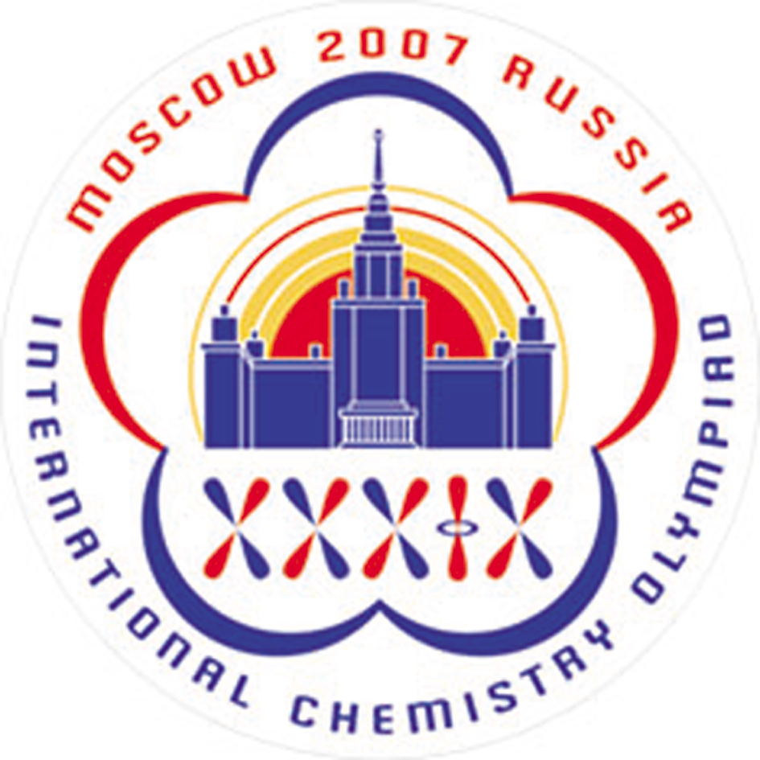

PRACTICAL EXAMINATION
PROBLEMS

JULY 18, 2007
MOSCOW, RUSSIA

21408 characters in Problems and Answer Sheets
General Directions

- safety rules follow them as in the Preparatory problems described, no eating or drinking is allowed in the lab.
- violating safety rules you get one warning, offend again: you are out.
- problem booklet 12 pages (incl. cover sheet and Periodic table of elements) with 2 problems. Start with problem 1.
- time 5 hours; 30 minutes warning before the end.
- answer sheets: 5 pages (incl. cover sheet).
- your name and student code write it on every answer sheet.
- answers only in the appropriate places of the answer sheets, nothing else will be marked. Relevant calculations have to be shown.
- use only the pen and calculator provided.
- results the number of significant figures in numerical answers must conform to the rules of evaluation of experimental error. Mistakes will result in penalty points even if your experimental technique is flawless.
- burette read it as accurately as possible.
- more chemicals needed? Ask your lab assistant. No penalty for this.
- Extra sample to be analyzed or broken column a penalty of 10 marks.
- questions concerning safety, apparatus, chemicals, organization, toilet break: ask your lab assistant.
- chemical waste put it only in the designated containers.
- official English-language version available on request for clarification only. Ask your lab assistant.
- after the stop signal put your answer sheets and spectra in the envelope (don’t seal), deliver them to your lab assistant. Keep the problem booklet together with the pen and calculator.
- You must stop your work immediately after the stop signal has been given. A delay of 5 minutes will result in zero points for the current task.
- During the Practical examination some of your glassware and plastics may have to be used more than once. Clean it carefully.

List of Chemicals

Reagent | Quantity | Placed in | Labeled
Task 1
Eluent 1 | 100 mL | Amber glass bottle* | Eluent 1
Eluent 1 | 1 mL | Plastic microtube | Eluent 1
Eluent 2 | 50 mL | Amber glass bottle* | Eluent 2
Eluent 2 | 1 mL | Plastic microtube | Eluent 2
Eluent 3 | 50 mL | Amber glass bottle* | Eluent 3
Eluent 3 | 1 mL | Plastic microtube | Eluent 3
0.5 М Carbonate buffer solution, pH 9.5 | 10 mL | Glass vial | NaHCO₃
0.5 М Tris-HCl buffer solution, pH 8.5 | 10 mL | Glass vial | Tris-HCl
Mixture of amino acids to be analyzed** | 1.2 mL | Plastic microtube | A number between 301 and 600
Ellmann reagent: 0.2 М Phosphate buffer solution containing 10 mM EDTA and 3 mM 5,5’-Dithiobis(2-nitrobenzoic acid), pH 7.0 | 10 mL | Glass vial | DTNB
Pauli’s reagent: solution of sodium 4-diazonium-benzenesulfonate in 0.1 M aqueous HCl | 1 ml | Plastic microtube | Pauli
Sodium hydroxide, 10% aqueous solution | 10 mL | Glass vial | NaOH 10%
8-Hydroxyquinoline, 5.2 mM solution in ethanol/n-butanol (9:1) mixture | 5 ml | Glass vial | 8-HQ
Sodium hypobromite, 0.24 M solution in 10% aqueous NaOH | 1.2 ml | Plastic microtube | NaBrO
2,4,6–Trinitrobenzenesulfonic acid, 3.4 mM aqueous solution | 1 mL | Plastic microtube | TNBS
8 M Aqueous urea solution | 1 mL | Plastic microtube | Urea
Task 2
HCl, standard solution, ~1 M (see exact value on the label) | 40 mL | Amber glass vial | HCl  <and exact concentration>
NaOH (to be standardized) | 200 mL | Amber glass vial | NaOH
Powdery sample to be analyzed** | 0.5 – 1 g | 150 mL beaker covered with watch glass | <number of workplace>
H₂O distilled | 400 mL | Plastic wash bottle | H₂O
H₂O distilled (shared between 2 students) | 30 mL | Glass drop bottle | H₂O
H₂O distilled (for common use) | 5 L | Bottle with tubing and clamp on top of the bench | H₂O
NaH₂PO₄, 15% solution (shared between 2 students) | 20 mL | Glass drop bottle | NaH₂PO₄ 15%
Bromocresol Green, 0.5% solution in 20% ethanol (shared among 3-4 students in a raw) | 30 mL | Glass drop bottle | Bromcresol green
Thymolphthalein, 0.5% solution in ethanol (shared among 3-4 students in a raw) | 30 mL | Glass drop bottle | Thymolphtalein
K₂C₂O₄, 15% solution (shared between 2 students) | 50 mL | Amber glass vial | K₂C₂O₄ 15%
*Fixed on the top shelf (do not try to remove), with connected tubing and clamp
**10 marks penalty for an extra portion of the sample

Components of Eluents 1 to 3
Eluent 1: 0.1 M aqueous sodium citrate, 50 mM sodium chloride, 40 mM thiodiglycol, 1 mM caprylic acid, 0.1% Brij-35; pH 4.9.
Eluent 2: 0.2 M aqueous sodium phosphate, 0.1% Brij-35; pH 7.0.
Eluent 3: 0.2 M aqueous sodium hydroxide.

Apparatus and Suppliers

Item | Quantity
Test tube rack | 1
Laboratory stand | 1
Chromatography column with ion-exchange resin | 1
Laboratory stand with white covering | 1
Double clamp for burette | 1
Ring for funnel | 1
25 mL Burette | 1
100 mL flask labeled “Waste” | 1
100 mL Volumetric flask | 2
100 mL Erlenmeyer flask | 2
Syringe with needle | 1
Graduated test tubes for collecting fractions and preparing mixtures | 50
96-well plate | 1
Pipettor (micropipette) with fixed volume of 0.1 mL | 1
Disposable tips (in blue plastic cup) | 20
Spectrophotometric cuvettes labeled “A1”, “B1”, “A2”, “B2”, “A3”, “B3” in cuvette holder | 6
10 mL Graduated plastic pipettes | 3
10 mL Glass pipette | 1
Pipette filler | 1
3-Way Bulb | 1
Glass rod | 1
Filter funnel | 1
Small funnel | 1
60 mL Amber glass vials for combined fractions (peaks) | 3
10 mL Measuring cylinder labeled “K₂C₂O₄ 15%” (shared between 2 students) | 1
10 mL Measuring cylinder (shared between 2 students) | 1
50 mL Measuring cylinder | 1
100 mL Measuring cylinder labeled “H₂O” (shared among 3-4 students in a row) | 1
Plastic plate with filters*** (shared among 3-4 students in a row) | 3 filters per student
Heating plate (for common use in a fume hood) | 6 plates per hood
Rubber protection tips (for common use a fume hood) | 6 pairs per hood
Spectrophotometer (shared by a group of students; see the number of the spectrophotometer to be used at your bench “SP____”)
Marker | 1
Ruler | 1
White sheet of paper | 1
***If needed, ask your lab assistant for extra filters.

Safety regulations, S-phrases, R-phrases
Disodium hydrogen phosphate | R:36/37/38 S:26-36
Ethylenediaminetetraacetic acid, disodium salt | R:36/37/38 S:26-36/37/39
Tris-HCl | R:36/37/38 S:26-36
Arginine | R:36 S:26
Cysteine | R:22
Histidine | S:22-24/25
Hydrochloric acid | R:34-37 S:26-36-45
Sodium 4-diazoniumbenzenesulfonate | R:1-37/37 S:26-36
Sodium hydroxide | R:34-35 S:26-36-37/39-45
8-Hydroxyquinoline | R:22-36/37/38 S:26-36/37
Ethanol | R:11 S:7-16
Butanol-1 | R:10-22-37/38-41-67 S:7/9-13-26-37/39-46
Sodium hypobromite | R31-34 S:26-36-45
5,5’-Dithiobis(2-nitrobenzoic acid) | R:36/37/38 S:26-36
2,4,6-Trinitrobenzene sulfonic acid | R: 1-22-36/38-43 S: 26-36/37
Sodium chloride | R:36 S:26
Thiodiglycol | R:36 S:26
Caprylic acid | R:34 S:26-27-45-36/37/39
Brij-35 | R:36/37/38 S:26-36
Sodium dihydrogen phosphate | S:22-24/25
Sodium carbonate | R:36 S:22-26
Calcium carbonate | R:41-37/38 S:26-39
Bromocresol Green | S:22-24/25
Thymolphthalein | S:22-24/25
Potassium oxalate | R:34 S:26-27-36/37/39

Risk Phrases

Indication of Particular Risks
  R1: | Explosive when dry
  10: | Flammable
  22: | Harmful if swallowed
  31: | Contact with acids liberates toxic gas
  34: | Causes burns
  35: | Causes severe burns
  36: | Irritating to the eyes
  37: | Irritating to the respiratory system
  41: | Risk of serious damage to eyes
  43: | May cause sensitization by skin contact
  67: | Vapors may cause drowsiness and dizziness

Combination of Particular Risks
R24/25: | Toxic in contact with skin and if swallowed
36/37/38: | Irritating to eyes, respiratory system and skin
36/38: | Irritating to eyes and skin
37/38: | Irritating to respiratory system and skin

Safety Phrases

Indication of Safety Precautions
  S13: | Keep away from food, drink and animal feeding stuffs
  22: | Do not breathe dust
  26: | In case of contact with eyes, rinse immediately with plenty of water and seek medical advice
  27: | Take off immediately all contaminated clothing
  36: | Wear suitable protective clothing
  39: | Wear eye/face protection
  45: | In case of accident or if you feel unwell, seek medical advice immediately (show label where possible)
  46: | If swallowed, seek medical advice immediately and show this container or label

Combination of Safety Precautions
  7/9: | Keep container tightly closed and in a well-ventilated place
  24/25: | Avoid contact with skin and eyes
  36/37/39: | Wear suitable protective clothing, gloves and eye/face protection
  37/39: | Wear suitable gloves and eye/face protection
Problem 1. Ion-exchange chromatography of amino acids

Ion-exchange chromatography is an important analytical and preparative method, which allows fractioning of charged substances. Interaction of ionic groups of the substances with counterions attached to the resin is behind the method. In this task you will have to carry out separation of a given mixture of three amino acids followed by quantitative assay of individual amino acids eluted from the column by using specific chromogenic reactions. Since queues of students are possible at spectrophotometers, we strongly suggest you starting the exam with Problem 1.

Three amino acids (see the structures above) are present in the mixture. These are histidine, cysteine, and arginine. Cross-linked sulfonated polystyrene is used as a cation-exchange resin (see the picture of the system below). At the beginning of the experiment the column is equilibrated with Eluent 1 (pH 4.9).

Procedure
Chromatography. Step 1
Apply the given solution of a mixture of amino acids to the column. First, open the stopcock to allow the solvent in the column draining into the Erlenmeyer flask labeled “Waste” so that the solvent is level with the top of packing material, still preventing the resin surface from drying off. Close the stopcock and carefully add the analyzed solution to the top of the column by using a syringe. Open the stopcock and let the sample soak inside the gel (drain the solvent into the “Waste” flask). Close the stopcock and add about 1 mL of Eluent 1 (corresponds to ~ 1 cm of liquid in the column) by carefully releasing the tubing clamp. Attach the top joint tightly, fixing the column with one hand and the adaptor with the other (be sure that the joint is fitted closely to the column). Replace the “Waste” flask at the stand with the test tubes in the rack. Release the tubing clamp and open the stopcock to let the eluent flow down through the column. Proceed with elution. (Always open the stopcock to start elution and close the stopcock to stop it).

Collect the fractions in the test tubes up to the volume of 2.5 mL (as shown in the Picture). If needed, label them with marker. After collecting each 4 to 8 fractions stop elution and carry out qualitative analysis of the collected samples.

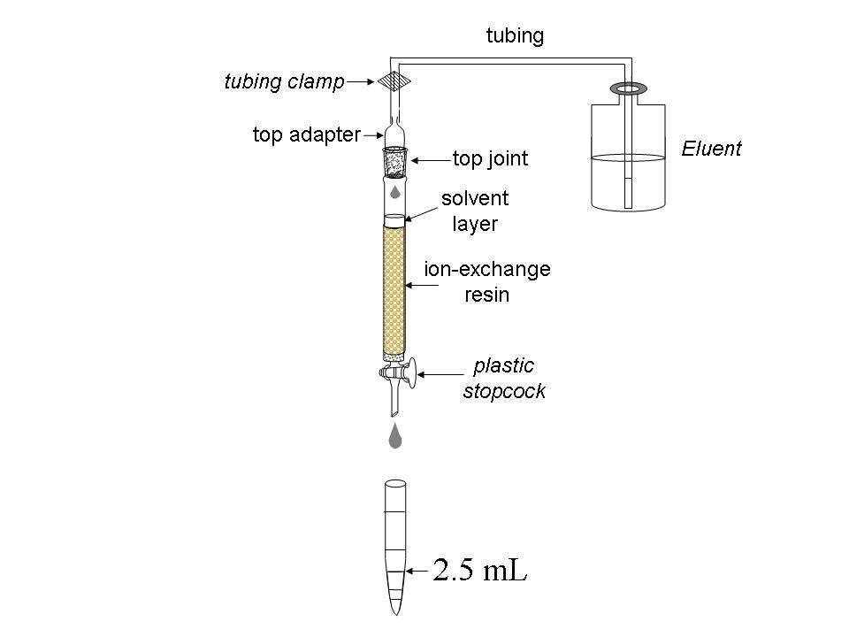
Qualitative analysis of samples
Qualitative assay of amino acids is based on the reaction of their α-amino groups with sodium 2,4,6–trinitrobenzene sulfonate (TNBS):
The assay is carried out in the wells of a polystyrene plate, each well corresponding to a definite test tube. Before starting the assay, mix 1 mL of TNBS solution with 10 mL of carbonate buffer solution and place 0.1 mL of the resulting mixture into half of the plate wells (from A1 to H5). Then add 0.1 mL of the analyzed fraction into a well. Start with A1 well and continue with B1, C1, etc (move top to bottom and left to right). If an amino acid is present in the analyzed fraction, intense yellow coloration will develop in the corresponding well within 3 min. Use the coloration in the first well as the reference. To reliably estimate the coloration, place the plate on the white sheet of paper.
Note: all aliquots of 0.1 mL should be added by using the pipettor. We expect you to use one tip for all fractions of a single peak.

1.1a Draw the profile of coloration intensity (qualitatively) on the plate sketch in the Answer Sheet. Use the following symbols: (-) – no coloration, 1 – weak coloration, 2 – moderate coloration and 3 – intense coloration. Keep drawing the profile during the whole chromatography process.

Continue collecting fractions and analyzing them until you get at least two wells with coloration as in A1 well, which will indicate that the first amino acid has left the column completely (end of the first peak).

Chromatography. Step 2
As soon as you are finished with collecting the first peak, change to Eluent 2. To do so, close the stopcock, fix the tubing clamp (Important!), disconnect the tubing leading to the bottle with Eluent 1 and connect the tubing leading to the bottle with Eluent 2. Attach the top joint tightly.

1.1b Indicate when the eluents have been changed by drawing lines between the corresponding wells on the plate sketch.

Continue elution, collecting fractions and carrying out qualitative analysis of samples as described above.

Chromatography. Step 3
As soon as you are finished with collecting the second peak, change to Eluent 3 as described in Step 2. Continue chromatography until the third amino acid leaves the column completely.

Stop chromatography by closing the stopcock and fixing the clamp.
Based on the results of qualitative analysis, choose the fractions which contain the amino acids.

1.1c Write down in the Answer Sheet the labels of wells corresponding to the chosen fractions.
1.2 Combine the fractions from each peak and measure the volumes of combined fractions using a measuring cylinder. Report the volumes of combined fractions excluding amounts used for the qualitative analysis. Write down the obtained results in the Answer Sheet.

Pour combined fractions in the amber glass vials labeled “Peak 1”, “Peak 2”, “Peak 3”. Prepare samples for quantitative spectrophotometric analysis as described below.

When finished with Practical exam, close the vials and leave them on the table. The combined fractions will be subsequently analyzed by lab staff.

Spectrophotometric analysis
For each probe, you should submit two cuvettes to the operator. Prepare the probes as follows.
Important! When storing, always put cuvettes in the cuvette holder! All cuvettes have 2 ribbed and 2 working vertical surfaces. While operating with cuvettes, do not touch working surfaces, otherwise you may get incorrect values of absorbance.

Assay 1 (peak 1). Cysteine concentration is determined by the Ellmann reaction:

Test tube A1 (Reference). Place 0.1 mL of Eluent 1 from plastic microtube into a test tube and add 2.9 mL of Ellmann reagent (DTNB).
Test tube B1 (Sample). Place 0.1 mL of the analyzed solution into a test tube and add 2.9 mL of Ellmann reagent (DTNB).
Mix the contents of the test tubes thoroughly and transfer each mixture to the corresponding cuvettes labeled A1 (for reference) and B1 (for sample).

Assay 2 (peak 2). Determination of histidine concentration is based on the ability of imidazole moiety to react with diazonium compounds (Pauli reaction).

Test tube A2 (Reference). Place 2.8 mL of Tris-HCl buffer solution into a test tube, add 0.1 mL of Eluent 2 from plastic microtube and 0.1 mL of Pauli reagent.
Test tube B2 (Sample). Place 2.8 mL of Tris-HCl buffer solution into a test tube, add 0.1 mL of the analyzed solution and 0.1 mL of Pauli reagent.

Mix the contents of the test tubes thoroughly and transfer each mixture to the corresponding cuvettes labeled A2 (for reference) and B2 (for sample).

Assay 3 (peak 3). Determination of arginine concentration is based on the ability of guanidinium moiety to react with some phenols under alkaline and oxidative conditions (Sakaguchi reaction).

Test tube A3 (Reference). Place 0.1 mL of Eluent 3 into a test tube and add 1.5 mL of 10% NaOH solution, 1 mL of 8-hydroxyquinoline solution and 0.5 mL of sodium hypobromite solution.
Test tube B3 (Sample). Place 0.1 mL of the analyzed solution into a test tube and add 1.5 mL of 10% NaOH solution, 1 mL 8-hydroxyquinoline solution and 0.5 mL of sodium hypobromite solution.

Shake the test tubes vigorously for 2 min (Important!) and observe formation of orange color. Add 0.2 mL of 8 M urea solution to each test tube, mix the contents and transfer about 3 mL of each mixture to the corresponding cuvettes labeled A3 (for reference) and B3 (for sample).

All mixtures should be analyzed by spectrophotometry not earlier than 10 min and not later than 2 h after preparation. Submit the set of 6 cuvettes to the spectrophotometer operator. In case of a queue at the spectrophotometer, ask the operator to put your student code on the list at the signboard. You will be invited by the operator in due time. Meanwhile, you can answer the theoretical question and start fulfilling Problem No 2.

In case your sample(s) have not been subjected to studies within the proper time interval (which is quite improbable), prepare the sample(s) afresh.

Get the print-offs with the spectra of your samples and check it. Sign the print-offs and get the operator’s signature.

1.3 Determine absorbance at the corresponding wavelengths and calculate the content (in mg) of each amino acid in the mixture you were given. The optical length is 1.0 cm. Complete the Answer Sheets taking into account that one mole of each amino acid gives one mole of the corresponding product.

Reference data:
The values of extinction coefficients:  Product of Ellmann reaction: 13600 M⁻¹cm⁻¹ at 410 nm  Product of Pauli reaction: 6400 M⁻¹cm⁻¹ at 470 nm  Product of Sakaguchi reaction: 7700 M⁻¹cm⁻¹ at 500 nm | Molar masses of the amino acids.  Cysteine 121 g/mol  Histidine 155 g/mol  Arginine 174 g/mol

1.4. Draw three resonance structures of the species responsible for mixture coloration as a result of Ellmann reaction.
Problem 2. Determination of carbonate and hydrogen phosphate in an abrasive sample

Na₂CO₃, CaCO₃ and Na₂HPO₄ are the main constituents of abrasive powders. In this task you will have to determine carbonate and hydrogen phosphate ions in an abrasive sample by two acid-base titrations.

First, the exactly known amount of hydrochloric acid (taken in an excess) is added to the sample. As a result, hydrogen phosphates are transformed into H₃PO₄, whereas carbonates into CO₂ which is further removed by boiling. Calcium ions initially present in the sample pass into the solution. Because of possible interference in subsequent analysis, they are precipitated as CaC₂O₄ and filtered off prior to the titration.

Next, the phosphoric acid formed is subjected to two titrations with pre-standardized NaOH solution and two different indicators: Bromocresol Green (BCG) and Thymolphthalein (TP). First, H₃PO₄ (and excess of HCl) is titrated to H₂PO₄⁻ ion, the endpoint lying in slightly acidic medium (pH of ~4.5). It corresponds to the color change of BCG from yellow to blue. The second titration proceeds till HPO₄²⁻ is formed. The endpoint of the second titration corresponds to the color change of TP from colorless to blue (moderately alkaline medium, pH of ~10).

The content of CO₃²⁻ ions in the sample is calculated by finding the difference between:
- the amount of the titrant equivalent to the initial amount of HCl (taken for the sample dissolution) and
- the amount of the titrant corresponding to the second endpoint (TP).
The content of HPO₄²⁻ is calculated by finding the difference between the amounts of the titrant consumed to achieve two endpoints (TP and BCG).

Procedure

Step 1. Dissolution of the sample and removal of CO₂
To the sample of the abrasive powder in a beaker covered with watch glass add 10.00 mL (exactly, with a pipette! Carefully, not removing the glass and avoiding losses because of splashing!) of ca. 1 mol/L HCl (see the exact concentration of the acid on the label). After the most intensive stage of gas evolution is completed, heat carefully the solution in the beaker (covered with watch glass) on a heating plate until the gas evolution stops. Then bring the solution to boiling and boil it carefully for 2-3 min.

Step 2. Precipitation of calcium
Remove the beaker from the plate; wash the steam condensate from the watch glass down to the beaker with distilled water. Add 1-2 mL of 15% K₂C₂O₄ solution with measuring cylinder. Put the beaker aside until the most part of the precipitate is formed (usually takes 10 to 20 min). Spend this time for standardization of the titrant solution of NaOH (see the procedure hereunder).

Step 3. Standardization of NaOH solution
Place with a pipette 10.00 mL of HCl solution into a 100 mL volumetric flask, make up to the mark with distilled water and mix. Fill the burette with NaOH solution. Transfer with a pipette 10.00 mL of the diluted HCl solution from the volumetric flask to an Erlenmeyer flask. Add 1-2 drops of Thymolphthalein solution and titrate with NaOH solution until blue coloration stable on swirling for 5-10 s appears.

Here and after. Repeat the titrations as necessary. It is desirable that the highest and the lowest titrant volume values differ not more than by 0.10 mL. Report all the final volume values with 0.01 mL accuracy.

2.1a Complete the table in the Answer Sheet.
2.1b Calculate the concentration of NaOH solution (in mol/L).

Step 4. Filtering off calcium oxalate
After the most part of CaC₂O₄ precipitates filter the precipitate off collecting the filtrate into a 100 mL volumetric flask. Slight turbidity in the filtrate is admissible, since small amounts of calcium oxalate do not interfere in the titration. Wash the filter with distilled water; make up the solution in the flask to the mark with distilled water and mix. Put the used filter into the waste basket.

Step 5. Sample titration against Bromocresol Green
Transfer with a pipette a 10.00 mL aliquot of the sample solution coming from the step 4 from the volumetric flask to an Erlenmeyer one, and add 3 drops of BCG solution. Prepare in another Erlenmeyer flask a reference solution by adding 3 drops of 15 % NaH₂PO₄ solution and 3 drops of BCG solution to 15-20 mL of distilled water. Titrate the sample solution with NaOH solution until the color coincides with that of the reference solution.

2.2 Complete the table in the Answer Sheet.

Step 6. Sample titration against thymolphthalein
Transfer with a pipette a 10.00 mL aliquot of the sample solution coming from the step 4 from the volumetric flask to an Erlenmeyer one. Add 2 drops of TP solution and titrate with NaOH solution until blue coloration stable on mixing for 5-10 s appears.

2.3 Complete the table in the Answer Sheet.

Step 7. Calculations

2.4 Calculate the mass of CO₃²⁻ in the sample.
2.5 Calculate the mass of HPO₄²⁻ in the sample.

Step 8. Additional questions to the problem
Answer the additional questions in the Answer Sheets.

2.6a Indicate one reaction (write down the equation) for a process interfering in the sample analysis you have carried out in the presence of Ca²⁺.

2.6b A list of mistakes possible at different steps is given in the table in the answer sheet. Indicate which of the mistakes can lead to errors in CO₃²⁻ and/or HPO₄²⁻ content determination. Use the following symbols: “0” if no error is expected, “+”or “–“ if the result is higher (positive error) or lower (negative error) than the true one.
